**Content:**

**CHAPTER 1**

**Point Cloud**

1.1 Basic concepts of point cloud

1.2 Types of point cloud

1.3 Sources of point cloud

1.3.1. LiDAR (Light Detection and Ranging)

1.3.1.1 Terrestrial LiDAR Scanning (TLS)

1.3.1.2 Aerial LiDAR Scanning (ALS)

1.3.2. Photogrammetry

1.3.3. Some advantages and disadvantages of photogrammetry over conventional surveying and mapping methods

1.4 Importance and use of point cloud

**CHAPTER 2:**

**3D Point cloud generation**

2.1 background on 3D point cloud generation

2.2 Structure from Motion

2.2.1Overview

2.2.2 Application

2.3 Multi View Stereo

2.4 3D models

2.4.1 Digital Elevation Model (DEM)

2.4.2 Digital Surface Model (DSM)

2.5 Software for point cloud generation

2.4.1 VisualSfM+ MeshLab

2.4.2 VisualSfM + CMPMVS

2.6 Comparison between point cloud produced by VisualSfM + MeshLab and VisualSfM + CMPMVS

**CHAPTER 3:**

**Software with complete pipeline**

3.1 GRASS-GIS

3.2 Objective

3.3 Data handling in GRASS GIS

3.4 point cloud processing in GRASS GIS

3.5 Our Observation

**CHAPTER 4**:

**Analysis of 3D Point Cloud**

4.1 Point Cloud Analysis

4.2 Segmentation of 3D Point Cloud

4.2.1 Edge based segmentation

4.2.2 Region growing segmentation

4.2.3 Hybrid segmentation techniques

4.2.4 Segmentation using Model Fitting

4.2.5 Machine Learning segmentation

4.3 Classification of 3D Point Cloud

4.4 Machine Learning as a tool for Point Cloud analysis

4.4.1 Unsupervised machine learning

4.4.2 Supervised machine learning

4.5 K-means clustering for Point Cloud segmentation

4.5.1 Objective

4.5.2 Methodology

4.5.3 Our Observation

4.5.4 Results

4.5.5 Inference

4.6 Regression for Point Cloud analysis

4.6.1 Logistic Regression

4.6.2 Objective

4.6.3 Methodology

4.6.4 Analysis of our model

4.6.5 Our observations

4.6.6 Results

4.6.7 Inference

4.7 A comparison between supervised & unsupervised approach: k-mean and logistic regression

4.8 Conclusion

**CHAPTER 5**:

**A command line application for point cloud processing:**

**Introduction**

This is a review of the processing of the point cloud data. Set of points in the 3D space is called point cloud. Point clouds processing is a relatively new idea and is at its developing stage. Point clouds are widely used in the representation of 3D structures in the form of a mass of points lying in the 3D space. Each of the points in the point cloud are accompanied by its attributes and based on those important inferences and relevant information can be derived for further use. Machine learning and various elements of artificial intelligence like computer vision has been contributing to a great extend to this processing part of point cloud. In the due course of our research we have explored the possibilities and limitations of machine learning algorithms in doing the task. To incorporate machine learning into this subject it is necessary that the data with which we are working is studied in a clear manner. With point cloud as the data to work with, its generation process has a lot to do with the parameters that the point cloud will provide.

Point clouds have their sources as either LiDAR or are obtained from 2D images obtained from cameras. With LiDAR the process is quite straight forward but in case of point clouds generated via images the process is a bit different. The data that is obtained from photogrammetric processes have limited usable parameters and this is the reason due to which processing is quite challenging. The point cloud generated by photogrammetric process using images which are captured in general from drones is done using different software such as VisualSfM which uses various computer vision algorithms. These software gives sparse and then dense point clouds which can be further imported to other software like MeshLab, CMPMVS for creating meshes. These point clouds are compared using various software like CloudCompare, etc. Other software like GRASS GIS, LASTools is used to create the DSM, DTM of the 3D models and compare them.

Analysis of the point cloud is a necessary step in point cloud processing and involves segmentation, which is the step in which we segment the point cloud into groups with similar traits and classification, in which the segmented groups are labeled. Machine learning techniques can be of great use for this purpose. Techniques like k-means clustering, logistic regression to classify and segment the point cloud data can be use. Models like k means clustering techniques are a part of unsupervised machine learning and hence do not require a training set of data. But supervised machine learning techniques does need training set of data which should be properly labeled. Outputs from such techniques are studied in the due course of the research.

Towards the end, a command line software is also created which is capable of segmenting the input data into required classes. The input it takes is in the .csv format and the output is also in .csv format. The software also comes with the extra features in which the user can provide their own training datasets to train the model and get the necessary output.

**Literature Report**

The concept of point cloud is relatively new but however is gaining popularity in a numerous realms of technology. It has been used to create CAD models, in metrology and also has finds its use in geographic information system or GIS. The creation of a 3D model in remote sensing and GIS involves creating Digital Surface Model or DSM and Digital Terrain Model or DTM of the area of survey. For the generation of point cloud various algorithms have been developed in the field of computer science. Point clouds can be generated by using sources like LiDAR or can be obtained via various photogrammetric techniques. Earlier generating process was quite sophisticated and costly as setting up LiDAR systems was not cost efficient. Further covering large areas of land to create 3D model involves solutions which incorporated aerial vehicles like aircrafts and helicopters which was not cheap. Recent developments in UAVs and drones have solved this problem to a great extend. Further technical development in the field of acquiring point data using LiDAR has reduced the cost. The other way of acquiring data is various photogrammetry techniques as stated. In photogrammetry cameras are used to capture images of the area and processed to form the point cloud. Structure from motion and various algorithms from Multi-View stereo are used to create the 3D model. Algorithms like Harris corner detector, scale invariant feature transform (SIFT) are used to detect the key points from the images collected. Harris corner detector is a computer vision algorithm that is used to detect and acquire information about the corner and features from the images. The SIFT algorithm was published by David Lowe in the year 1999 and also serves as one of the feature detection algorithm in computer vision to detect and describe local features in image. Various mathematical concepts like gradient and Laplacian are used within this algorithm. The concept of DoG (Difference of Gaussian) plays a key role in this process. The resolution of the images does play a role in the generation of the model. Images with high quality and high resolution are usually better. Overtime various commercial and open source softwares are used to produce the 3D models. Open source software like VisualSfM, OpenDroneMap, CMPMVS and MeshLab are used for the process. Commercial software like Pix4D also is used to convert images directly into 3D models.

After the 3D model is formed a necessary process is to draw useful information from the point data. For this classification and segmentation is required. Various ways for segmenting the point clouds have evolved. Many libraries have been developed like PCL, PDAL and CGAL which provides functions which can operate directly on the point cloud. Many filters are offered by these libraries which can be applied to the data points. Certain libraries like PDAL also offers the flexibility to form pipelines in which a number of filters can be clubbed together to get a final output. Softwares like GRASS GIS, CloudCompare and QGIS with their various plug-ins can do the analysis of the point clouds in an effective manner. CloudCompare comes with plugins like qCANUPO, qPCL etc. which are plugins for point cloud classification and PCL library respectively. LASTools also provides such features. Further it can be set as a plugin for QGIS and can be used in the GUI provided by QGIS.

However it must be stated that application of point cloud and its processing is a relatively new idea and almost none of the services yet are accurate to a cent percent. And a lot of grounds are left to be covered in this idea.

**Objective**

The objective of this research can be represented as follows:

● Construction of Digital Surface Model using open source software.

● Comparison between the DSMs made by different software with statistical data.

● Analysis of point cloud using various machine learning techniques.

**Chapter 1**

**Point Cloud**

* 1. **Basic concepts of point cloud**

3D point cloud is basically a collection of points in a 3 dimensional space. These points are extracted from 2D images and by first extracting key points from each image, matching the key points in corresponding image pairs and finally triangulating to get initial sparse 3D point clouds. The dataset from where these points are collected are images which forms a sequence such that every consecutive image have a forward overlapping of 80-85% and sidelap of at least 30-40%. If there is no overlapping between the images then no such points can be found. Note that the points in the point clouds are not just mere collection of coordinates but also contains other attribute information.

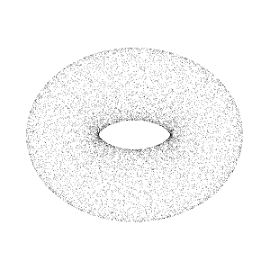

Fig: a point cloud

**Ground Control Points**

In order to generate an accurate position of data in 3 dimensional space (x, y, z) GCPs are used as reference points .GCP coordinate data is used to align and geo-reference photogrammetric data to their correct geospatial position. To choose GCP, choose features that can help us identify accurately at the resolution of the raw image. Plus, consider those which are close to the ground but we should avoid considering shadows as GCP. We can collect GCPs from a variety of elevations and in an area of overlap between two or more images when possible. The same ground coordinate (GCP) collected in multiple images helps to produce a more accurate model.

* 1. **Types of point cloud**

There are two types of point clouds which are categorised as

●Sparse point cloud

●Dense point cloud

**Sparse point cloud**: The sparse point cloud is the measure of set of points as data file which can be rendered directly but for use in most 3D applications. There is a need to carry out surface reconstruction i.e. construction of dense point cloud. It is used to find out which image pairs are overlapping. It can be further modified to form a dense point cloud using certain algorithms. This can be done in certain tools like VisualSFM etc.

**Dense point cloud**- Sparse point cloud are converted to dense form to make 3D models and can be helpful in positioning 3D objects into a scene. It is used to create the depth maps for the overlapping pairs found out through sparse point cloud and merged them together. In dense form, the point cloud is relatively more densified and help in 3D construction of models.

**1.3 Sources of point cloud**

There are mainly two sources each involving different set of techniques to work upon to produce point cloud.

**1.3.1. LIDAR (Light Detection and Ranging)**

LIDAR is a remote sensing method to obtain a point cloud by measuring the distance to a target by illuminating the target with laser light. Here the returns i.e the reflected pulses are measured with the sensor. The time duration of the returns and the difference in wavelengths gives us the information for the creation of a 3D representation of the targeted structure. LIDAR has been typically used in forestry for large-scale remote sensing of forest canopy structures, estimating tree height distributions, canopy bulk density, and leaf area. In this the data is obtained in some kind of binary format so initially the data processing involves converting the collected laser data from binary to ASCII format.

Types of LIDAR:

* Terrestrial LIDAR scanning
* Aerial LIDAR scanning

**1.3.1.1Terrestrial LIDAR Scanning**

The terrestrial LIDAR scanning provides a collection of points for the point cloud. It uses a ground-based or tripod mounted light radar. It measures the 3D position of the structure by recording the time taken by the pulses sent to return back to the sensor. The sensor continuously emits beam which is directed by rotating or oscillating mirrors. This helps us to get the location of the points in 3D representation. This LIDAR scanning is also known as ground-based LIDAR. It provides very accurate metrics of tree and canopy (e.g. timber volume, tree height and diameter, etc). It is used in several fields like building surveying, mining applications, etc.

**1.3.1.2. Aerial LIDAR Scanning**

The aerial LIDAR scanning is also known as airborne LIDAR scanning. Here the scanner is fitted into an aircraft during its flight. During this, pulses are sent from the sensors to the structures. As the sensor is moving height, location and orientation of the instruments must be included to determine the position of the laser pulse at the time of sending and the time of return. This helps to create a point cloud of the targeted structures. The sensors are typically fitted in a lightweight pod which can accommodate additional equipment, such as an IMU for more accurate data capture and industrial cameras so high definition photos can be overlaid onto point clouds allowing the user to produce a more detailed 3D picture. Aerial LIDAR scanning is considered to be the most accurate method of creating Digital Elevation Models and Digital Surface Models.

**1.3.2. Photogrammetry**

Photogrammetry technique is a technique where two or more than two 2D photographs are taken from different orientations and with the help of them 3D spatial dimensions are extracted. It is the science of making measurements from photographs, especially for recovering the exact positions of surface points. It is used to measure distances between objects, and photogrammetry software can utilize images to create 3D renderings. This information can then be used to produce CAD (Computer Aided Design) data via production of 3D point cloud. The fundamental principle used by photogrammetry is triangulation. By taking photographs from at least two different locations, so-called “lines of sight” can be developed from each camera to points on the object. Earlier photogrammetry technique was conducted by fitting the in an aircraft but in modern times it is conducted by the use of drones.

 There are 2 distinctive types of digital photogrammetry:

* Close-range
* Aerial

Close range digital photogrammetry involves the use of a camera mounted on a tripod stand of vehicle or a hand held devise. In this case, the individual images are captured by the camera in order to create a 3D picture of the object. This type of photogrammetry technique called 3D Texturing which can be used to create building facades (3D textured building) or any such physical objects those can be viewed from the ground level.

Aerial photogrammetry is done by mounting the camera in an aircraft and subsequently taking photographs of the ground. It is typically done in a straight-down manner. The shutter of the camera is put in to action every few moments as the aerial vehicle moves along the flight path. Previously, film cameras were deployed to capture the images however with the advent of digital technology, digital camera are used in a more efficient manner. These cameras come in very handy when it comes to manipulating the captured images in to something more useful. No matter what type of camera is utilized the captured frames are overlapped with the subsequent chain of frames. These chains of images are then metaphorically ‘stitched together’ in to a seamless order to make a wholesome picture of the object in interest. Typically, aerial photogrammetry is deployed for mapping terrain, Planimetric data creation, and 3D layer capturing

**Overlap:** is the amount by which one photograph includes the area covered by another photograph, and is expressed as a percentage. The photo survey is designed to acquire 60% forward overlap (between photos along the same flight line) and 30% lateral overlap (between photos on adjacent flight lines)

The number of data points to be calculated can be controlled by the user in photogrammetry software. After 3D point cloud data is generated post processing is done like cleaning and smoothing the cloud points using software like VisualSFM. Out of these point clouds triangular meshes are generated using Delaunay triangulation. Then surfaces are generated and if required solid geometry is created.

Stereophotogrammetry is a special case that involves estimating the three dimensional coordinates of the points of an object, involving estimating measurements made in two or more photographic images taken from different positions.

**1.3.3. Some advantages and disadvantages of photogrammetry over conventional surveying and mapping methods**

**Advantages:**

* It provides a permanent photographic record of conditions that existed at the time the aerial photographs were taken. Since this record has metric characteristics, it is not only a pictorial record but also an accurate measurable record.
* If information has to be re-surveyed or re-evaluated, it is not necessary to perform expensive field work. The same photographs can be measured again and new information can be compiled in a very timely fashion. Missing information, such as inadequate offsets for cross sections, can be obtained easily.
* It can provide a large mapped area so alternate line studies can be made with the same data source can be performed more efficiently and economically then other conventional methods.
* It provides a broad view of the project area, identifying both topographic and cultural features.
* It can be used in locations that are difficult, unsafe, or impossible to access. Photogrammetry is an ideal surveying method for toxic areas where field work may compromise the safety of the surveying crew.
* An extremely important advantage of photogrammetry is that road surveys can be done without closing lanes, disturbing traffic or endangering the field crew.
* Intervisibility between points and unnecessary surveys to extend control to a remote area of a project are not required. The coordinates of every point in the mapping area can be determined with no extra effort or cost.

**Disadvantages:**

* Weather conditions (winds, clouds, haze etc.) affect the aerial photography process and the quality of the images.
* Hidden grounds caused by man-made objects, such as an overpass and a roof, cannot be mapped with photogrammetry. Hidden ground problems can be caused by tree canopy, dense vegetation etc. The information hidden from the camera must be mapped with other surveying methods.

**1.4 Importance and use of point cloud**

Point clouds are used for many purposes, including creating 3D CAD models for manufactured parts, for metrology and quality inspection, and for a multitude of visualization, animation, rendering and mass customization applications. They are used to create 3D meshes and other models which can be used for various other fields like medical imaging, 3D printing, manufacturing, 3D gaming and various virtual reality applications. They also support the design process by providing the real world context where we can recreate the referenced objects. Once a point cloud is attached to a drawing, we can use it as a guideline for drawing, change its display, or apply colour stylization to distinguish different features. With the help of point clouds we can create a 3D model out of it which can be further segmented and classified to extract various relevant semantics.

In the recent times computer vision has evolved significantly and it is not longer that we will have automated vehicles. Efficient application of point cloud to trace the environment for the autonomous body to get a 3D model of the surrounding can be used in numerous instances like avoiding obstacles, object recognition and also tracking objects in the real time. These can find major application in ideas like self driving car.

Robots with capabilities to create and analyze point cloud can be utilized in various fields like defense and also in various factories.

**Chapter 2**

**Generation of 3D point cloud**

**2.1 Background on 3D point cloud generation**

The process of 3 dimensional point cloud generation involves acquisition of information from the 2 dimensional data i.e. images and creating a 3 dimensional model from it. In simpler words, it is the process of 3D reconstruction of scene given 2D images overlapped images of the area under consideration. The reconstructed 3D scenes in the form of 3D dense point clouds could be used to generate important data products such as Digital Elevation Model (DEM) and Digital Surface Model (DSM) which can be used for various applications where 3D surface models are required. Further, these models find utilization in various fields from general surveys to construction and others realms as well.

The process for generation of 3D point clouds involves various pipelines and needs in-depth understanding of important concepts like photogrammetry, structure from motion (SFM) and Multi View Stereo which processes the information obtained from 2D images.

Photogrammetry coupled with Computer vision algorithms and techniques forms the basis for the entire process. According to the American Society for Photogrammetry and Remote Sensing, it is defined as, "the art, science and technology of obtaining reliable information about physical objects and the environment through the process of recording, measuring and interpreting photographic images and patterns of electromagnetic radiant imagery and other phenomena". It involves extraction of 3 dimensional measurements from 2 dimensional data. It encompasses methods of image measurement and interpretation in order to derive the shape and location of an object from one or more photographs of that object. Photogrammetry used concepts from various realms like optics and projective geometry. In principle, photogrammetric methods can be applied in any situation where the object to be measured can be photographically recorded. Traditional aerial photogrammetry involves acquisition of images of an area from the satellites and deriving information from them. This is also called orbital photogrammetry. The other form which is called Close-range photogrammetry refers to the collection of photography from a lesser distance. For this purpose Unmanned Aerial Vehicles (UAVs) are used to gather images of the area. This method has been very useful in places where there is heavy cloud cover and where traditional surveying methods are dangerous to perform.

Structure from motion (SFM) is the technique of processing of the 2 dimensional data obtained in the process of photogrammetry. It involves the concept which is deriving information about the 3 dimensional structure of the area from a sequence of images provided in order to create the 3 dimensional model of it. It involves computation of camera position from the images. The projection of the model on a series of Images of the subject from various viewing angles is analyzed to gather information which is then passed through various processes to create a 3 dimensional model from it. Algorithms like Harris Corner, scale invariant feature transform etc. are finds wide utility in this stage.

Multi view stereo (MVS) is the process of construction of three dimensional models from a sequence of images with known camera calibration, both internal and external. The information about location, orientation and various camera parameters that are explored in SFM are feed into MVS for the further processing. Multi View Stereo is capable of producing very highly detailed 3D models from the images. A large set of images are taken as input and a highly detailed 3D model is developed that can be inferred from the images under some basic assumptions, one being scene rigidity. A number of methods are used for the geometry representation of the 3 dimensional model like polygon meshes, voxels etc. in polygon meshes points of the point cloud are join together based upon certain conditions and a surface is formed subsequent filling of the empty space can be done in order to obtain a smooth surface. While voxels can be defined as a unit of the grid representation in the three dimensional space. It is same as what pixel does but here the representation is in a 3 dimensional space. It contains graphical information. But unfortunately due to the lack of dataset there are restrictions in the various algorithms involving Multi View Stereo.

**2.2 Structure of Motion**

Structure of Motion is a photogrammetric range imaging technique for estimating three-dimensional structures from two-dimensional image sequence that may be coupled with local motion signals .It is a technique which utilizes a series 2-dimensional images to reconstruct the 3-dimensional structure of a scene or object. SFM can produce point cloud based 3-D models similar to LiDAR. This technique can be used to create high resolution digital surface models (including digital elevation models) and models of objects with consumer grade digital cameras. The relatively new technique has been made possible by advances in computers, digital cameras and unmanned aerial systems (UAS). Together, these advances have now made it feasible for a wide range of users to be able to generate 3-D models without extensive expertise or expensive equipment.

**2.2.1. Overview**

SFM is based on the same principles as stereoscopic photogrammetry. In stereophogrammetry triangulation is used to calculate the relative 3-D positions (x, y, z) of objects from stereo pairs. Traditionally these techniques require expensive specialized equipment and software.

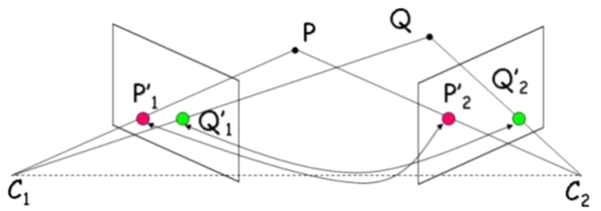

Figure: 2.1: Common points (P and Q) are identified on each image. A line of sight or ray can be constructed from the camera location to the point on the object. It is the intersection of these rays (triangulation) that determines the three-dimensional location of the point*.*

To create a 3-d reconstruction one simply needs many images of an area or an object with a high degree overlap, taken from different angles. The camera doesn’t need to be specialized, standard consumer-grade cameras work well for SFM methods. The images are often be taken from a moving sensor (UAVs for example), but can also be taken by a person or multiple people are different locations and angles.

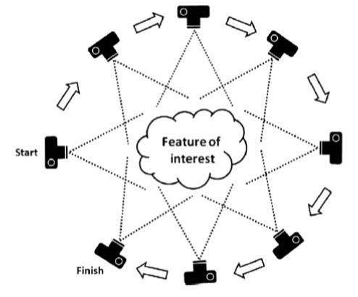

Figure 2.2: the process of taking images

Specialized software packages are able automatically identify matching features in multiple images. These distinctive features are often corners or line segments. These features are tracked from image to image and are used to produce estimates of the camera positions and orientations and the coordinates of the features. This produces a point cloud of x, y, z coordinates for features.

While the minimum requirement is for features to be visible in a minimum of three image, obtaining as many images for SFM input as possible (within in reason and feasibility) is recommended. For the fastest processing and model quality, all of the images should be taken at the same time with same camera, but this is not a requirement. SFM methods have been employed using crowd-sourced images to create 3-Dd models of historical building and other monuments. The 3-d point clouds are often generated in a relative ‘image-space’ coordinate system, but can aligned to a real world coordinates system using ground-control points (GCPs) and georeferenced imagery.

**2.2.2. Application:**

There are many applications for SFM methods. SFM to can be used to create orthophotograph, mosaics 3D point clouds, and digital elevation models. Orthophoto mosaics have many applications in mapping and photogrammetry. 3-D point clouds have been used to determine tree biomass, analyze geology. Digital elevation models created from SFM processing are generally high resolution and can be used to detect topographic changes to monitor glacial, fluvial, coastal, hill slope environments. In addition to natural resource and geospatial applications, SFM is also used extensively in robotics and self-driving vehicles.

# 2.3 Multi View Stereo:

# The goal of multi-view stereo is to reconstruct a complete 3D object model from a collection of images taken from known camera viewpoints. Multi-view stereo algorithm is used in photogrammetry for the recreation of dense point cloud of a static scene. Multi-view stereo can be performed by using the sparse reconstruction software Visual technique. The algorithms are used to create a highly detailed 3D model from the images and SFM to get the camera parameters and the depth map generation. MVS algorithms need additional knowledge in order to make the reconstruction problem well posed. In particular, MVS algorithms require that every input image has a corresponding camera model that fully describes how to project a 3D point in the world into a 2D pixel location in a particular image. The most commonly used camera model for MVS is the pinhole camera model.

Over the last few years, a number of high-quality algorithms have been developed, and the state of the art is improving rapidly. Unfortunately, the lack of benchmark datasets makes it difficult to quantitatively compare the performance of these algorithms and to therefore focus research on the most needed areas of development. It is unlike the case in binocular stereo, where the goal is to produce a dense depth map from a pair of images. It involves multiple images to obtain theresult. Here, however, a database of images with ground-truth results has made the comparison of algorithms possible and hence stimulated an even faster increase in algorithm performance.

Multi-view stereo algorithm was introduced as a improvement to the insufficiencies of two-view stereo. Instead of capturing two photographs from two different viewpoints, multi-view stereo would capture more viewpoints in-between to increase robustness, e.g. to image noise or surface texture. In the case of MVS, where the camera parameters are known, solving for the 3D geometry of the scene is exactly equivalent to solving the correspondence problem across the input image.

**2.4. Three dimensional models**

Three dimensional models are an important part of Geographic Information Systems as it involves study of various geographic data. There are various models which are implemented for various applications. Two forms of models are discussed in this report as follows:

**2.4.1** **Digital Elevation Model (DEM):** Digital Elevation Models are digital representation of earth’s topography. These models are a type of raster GIS layer. In a DEM, each cell of raster GIS layer has a value corresponding to its elevation (z-values at regularly spaced intervals). In layman words DEM can be defined as the 3D model of earth surface. It is formed based upon the height of the earth surface with respect to a reference called the vertical datum. The term vertical datum can be defined as a surface of zero elevation from which any elevation is measured. Digital Elevation Model or DEMs are bare earth models where the non ground points are filtered out like bridge, buildings and vegetations are also not included.

DEMs find a number of applications in various fields. DEMs are very important while studying the earth’s topography and overall geography of the earth’s surface. DEMs can be used to derive topographic attributes, geomorphometric parameters, morphometric variables or terrain information in general. In combination with other spatial data, digital elevation models are an important database for topography-related analyses or 3D video animations. They are also important in generating the orthophoto and then further image analysis.

**2.4.2** **Digital Surface Model (DSM):** Digital Surface model gives the 3D model of the earth surface along which includes the bare earth surface along with various structures on it like various man-made constructions, vegetation. Thus DSM captures the natural and built features of the earth surface.

Digital Surface Models are important and are used in aviation. In aviation, DSMs can determine runway obstructions in the approach zone. For construction purposes proper management of vegetation should be done this can be done through DSMs. In areas like Kaziranga National Park where poaching of one horn rhinoceros is a major concern suitable measures to stop the menace can be well contributed by the DSMs of the area where there is high movement of the animals and corresponding measures can be taken. Urban planners use DSM to check how a proposed building would affect the view shed of residents and businesses.

**2.5. Software for 3D model generation**

For creating the point cloud and further processing it to create the DSM and DTM we have used various software and combinations of it as output from one is fed into the other one.

## 2.5.1. VisualSFM

## Visual SFM is an open source GUI application. It uses the concept of structure of motion to create 3D point cloud of the 2D images. It creates a sparse point cloud of the imported 2D images. This is done after the keypoint identification and descriptor assignment. Visual SFM does pair-wise matching of the points to generate a point cloud. The sparse point cloud generated can be densified further to form a dense point cloud. It uses certain algorithms like SIFT (Scale Invariant Feature Transform). The dense point cloud generated is then converted to mesh in another software tool MeshLab.

## VisualSFM gives two main outputs -

## .out file (bundler format) which stores the calculated (solved) camera’s positions and a sparse point cloud representing the points in the scene that the software used to determine the camera positions.

**.**plyfile which stores a denser cloud of points, each with position, color and normal (a vector perpendicular to the surface the point is on) data.

## VisualSFM will produce generally better results the higher-resolution your images are, BUT, after 3200px, the results get worse.

**VISUAL SFM Workflow**

1. Importing the images

Images can be imported in Visual SFM by various methods, available both through the menu bar and as shortcuts

1. Load NView Match (shortcut or through the SFM menu tab)

• Choose a .txt file containing relative image paths for all relevant images.

• Choose “All JPEGs in Folder” from the format menu and select any file in the folder containing all relevant images.

1. Open Multiple Images (shortcut or through the File menu tab)

• This can be done multiple times to import all images.

Throughout the workflow the Log Window displays relevant information related to each process and also informs us of the progress during that process.

2. Matching the images

The next step is to have Visual SFM detect features in each image, and find matches. The tool for this step is called Compute Missing Matches and is accessible through the SFM menu under Pair wise Matching.

Visual SFM completes two things here:

• Scale Invariant Feature Transform (SIFT)

• Full pair wise image matching.

1. Creating the Sparse Reconstruction

Now the matches are turned to points in 3D space. This can be achieved by going to the SFM menu and selecting Reconstruct Sparse or by using the Compute 3D Reconstruction shortcut. This process is not as much time consuming as the matching one. Once the sparse point cloud is constructed we are able to navigate around the 3D space using the mouse.

* 1. Specifying Ground Control Points

At this point, after creating a sparse 3D model, we can enter ground control point (GCP) data in order to scale and orient the point cloud. This process works best if the input coordinates do not contain too many significant figures. We began specifying GCPs in Visual SFM by either clicking on the shortcut on the right that looks like a carpenter’s square or by going to the SFM menu and in More Functions selecting GCP-based Transform.

5. Creating the Dense Reconstruction

We can construct a dense point cloud by going to the SFM menu and selecting Reconstruct Dense or by clicking on the Run Dense Reconstruction shortcut. This creates an .nvm file. Once it is complete we can view the dense cloud by going to the View menu and selecting dense 3D Points. We can see some large gaps in the dense point cloud due to the reduction in the resolution of the images and some sub-aqueous areas were difficult to render for the software because they are both dark and somewhat featureless in the images.

1. Exporting the 3D Model

Once the dense point cloud is created and automatically saved in VisualSFM, certain software like MeshLab, CMPMVS, Cloud Compare, etc. are used to create 3D coloured meshes from the point cloud.

**2.5.2. MESHLAB**

MeshLab is open source software. It is used to create the mesh of the dense point cloud by joining the points using many meshing technique. They are built on the principles of the Delaunay Triangulation, together with the rules for adding vertices, such as Ruppert’s algorithm. It offers features for processing raw data produced by 3D digitalization tools and for 3D printing. The Poisson reconstruction algorithm is used to create the mesh surface. This creates a very smooth surface that robustly approximates the noisy data. The visualization features of MeshLab can help in graphically present the peculiar characteristics of a 3D model. It is possible to control the camera perspective /orthographic view parameters, and use predefined canonical views.

The two types of output that the software provides are:

**.obj** file of a mesh (with UVs) that can be easily interchanged with various 3D softwares

**.png** file of varying size representing the texture of the mesh

Steps for obtaining a mesh in MeshLab:

a common prob-

lem of many open source tool is that either they are small

enough to be created and maintained by a small team, or,

if they require a considerable development effort, the devel-

oper team need to be economically supported in some way

* After importing the dense point created in visual SFM to MeshLab, the unwanted parts of the point cloud are removed using certain tools available in the software.
* Then the normals from the points are calculated for the generation of the mesh.
* Then we use the Poisson surface reconstruction algorithm to create a mesh of the point cloud.
* The texture is applied using certain tools finally.

MeshLab has different features like:

* 3D Acquisition: Reconstruction

The process of transforming independent acquisitions, or point clouds, into a single-surface triangulated mesh can be fulfilled by using different algorithmic approaches. MeshLab provides several solutions to reconstruct the shape of an object like Screened Poisson.

* 3D Acquisition: Colour Mapping and Texturing

Colour information may be as important as geometry, but several technologies do not provide accurate appearance data. MeshLab contains a pipeline for the alignment and projection of colour information onto a 3D model.

* Raster Layers: Integration with Images

Raster Layers have been introduced in MeshLab to allow going beyond the standard 3D model. MeshLab users can import in a project also images and other 2D entities. These Raster Layers are used to project colour information on the 3D model and other tasks.

a common prob-

lem of many open source tool is that either they are small

enough to be created and maintained by a small team, or,

if they require a considerable development effort, the devel-

oper team need to be economically supported in some way

a common prob-

lem of many open source tool is that either they are small

enough to be created and maintained by a small team, or,

if they require a considerable development effort, the devel-

oper team need to be economically supported in some way

a common prob-

lem of many open source tool is that either they are small

enough to be created and maintained by a small team, or,

if they require a considerable development effort, the devel-

oper team need to be economically supported in some way

**2.5.3. CMPMVS**

CMPMVS is multi-view software. It is able to produce meshed surfaces directly. It seems it only works for CUDA-enabled systems. CMPMVS was developed by Michal Jancosek and Tomas Pajdla. It is a multi-view reconstruction software specifically designed to reconstruct weakly supported surfaces, such as transparent glasses or obscured ground planes. It requires known camera positioning and orientation information in our case supplied by VisualSFM. The dense point cloud created in Visual SFM is imported in this software to produce the mesh surface. Using a plane sweeping algorithm, CMPMVS creates a depth map for each image, which is then used to create a point cloud and finally a three-dimensional mesh.

STEPS:

## •we have used VisualSFM   to produce the 3D sparse point cloud

## •In VisualSFM, save the dense 3D reconstruction output to folder of type NVM.CMP

## •Install CMPMVS version 0.6

## •Configure mvs.ini (output from VisualSFM) according to type of products that needs to be generated

## •example for DEM, set doComputeDEM=TRUE; For, Orthomosaic, set doComputeOrthomosaic=TRUE

## •Once .ini file has been configured

## •Open command prompt, Go to CMPMVS installation path

## •Execute >>cmpmvs “path to .ini”

**VisualSFM and CMPMVS give the following results:**

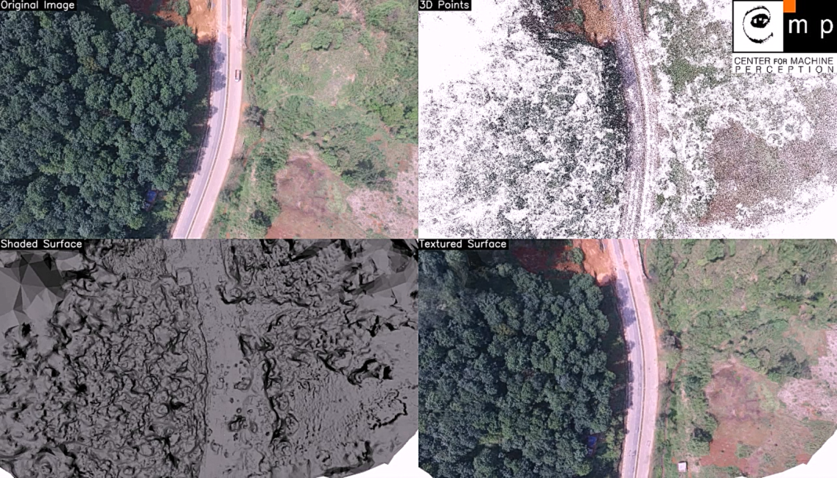

Figure: 2.3 output from CMPMVS

**2.6** **Comparison between point clouds produced by VisualSFM + MeshLab and VisualSFM + CMPMVS**

We have used VisualSFM for the point cloud formation and constructed sparse and dense point cloud using it. To get digital surface model or the DSM from the point cloud we have used other software like MeshLab and CMPMVS. The comparison between the various combinations to obtain the required product is given below.

|  |  |  |
| --- | --- | --- |
| pappdddjdjdnfdnbdpp | VisualSFM + CMPMVS | VisualSFM + MESHLAB |
| Xmax | 3.799 | 9.648 |
| Xmin | -7.258 | -8.382 |
| Xmean | -2.0711 | -2.568 |
| Ymax | 4.148 | 4.187 |
| Ymin | 0.436 | -0.99 |
| Ymean | 3.182 | 3.119 |
| Zmax | 3.674 | 7.883 |
| Zmin | -2.438 | -2.673 |
| Zmean | 0.805 | 1.129 |
| Rmean | 114.99 | 104.64 |
| Gmean | 110.88 | 94.947 |
| Bmean | 107.17 | 92.392 |
| N | 152008 | 41508 |
|  |  |  |

Table 2.1: Comparison of the statistics from the two set of results produced

Where,

N gives the total number of samples in the point cloud Xmin gives the minimum value of X coordinate; Xmax gives the maximum value of X coordinate; Ymin gives the minimum value of Y coordinate; Ymax gives the maximum value of Y coordinate; Zmin gives the minimum value of Z coordinate; Zmax gives the maximum value of Z coordinate; Zmean gives the mean value of Z coordinate; Rmean gives the mean value of red; Bmean gives the mean value of blue; Gmean gives the mean value of green;

a common prob-

lem of many open source tool is that either they are small

enough to be created and maintained by a small team, or,

if they require a considerable development effort, the devel-

oper team need to be economically supported in

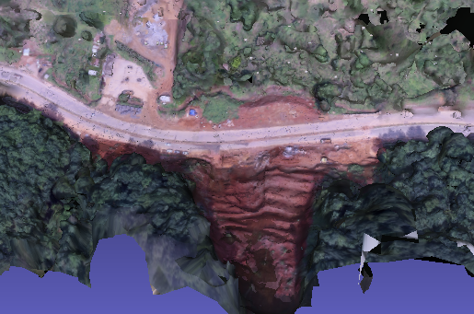 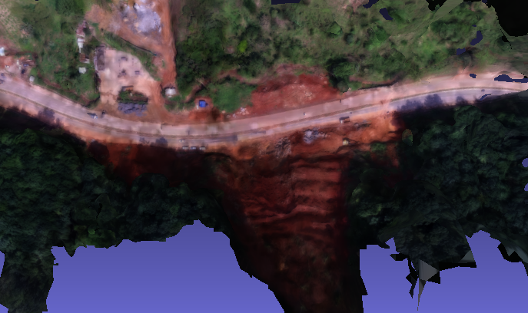

Figure 2.4: Comparison between VisualSFM + MeshLab and VisualSFM + CMPMVS

**CHAPTER 3**

**Software with complete pipeline**

**3.1 GRASS GIS**

GRASS GIS commonly referred to as GRASS (Geographic Resources Analysis Support System), is an open source Geographic Information System (GIS) used to produce graphics and maps. It also has a great utility in geospatial data management and analysis, image processing, spatial modeling, and visualization. GRASS supports both raster and vector data in two and three dimensions.

**3.2 Objective**

* To understand the 2D image of the structure along with its statistical data and histograms.
* To create and understand the 3D form of the structure and create the DTM and DSM from it.

**3.3 Data handling in GRASS GIS**

The GRASS GIS stores its data in a very specific and arranged way and in a very specific sequence.

* A GRASS GIS SPATIAL Database: it’s a database usually named as “grassdata” on which new directories of new projects are stored.
* Location: it’s a directory within the file grassdata which stores data related to one geographic location or a project.
* Mapset: it’s a collection of maps that is formed in the due course of the project and is within the location directory.

After installing the add-ons required to perform the tasks, the data provided is imported into GRASS GIS. The orthophoto file is imported and all the imported layers are added to GUI automatically, if not, we added them manually. Computational region is an important raster concept in GRASS GIS. In GRASS a computational region is set, subsetting larger extent data for quicker testing of analysis or analysis of specific regions based on administrative units. After setting the computational region, we can set the resolution separately. We can also check the numeric values of the computational region by certain commands on the console line, which gives the information about the no of cells, rows, columns etc.

* GRASS GIS comes with an extra edge that from the orthophoto of the area a lot of information regarding the density of point cloud that is number of point cloud per cell can be derived. It also provides with a histogram and various statistics which showcase that comes along with it. The statistical data provides the information about the number of points per call, the total number of point data, etc.

**3.4 Point cloud processing in GRASS-GIS**

The entire process in grass can be completed using the console provided by the GRASS GIS GUI

1. We imported the orthophoto which is in the .tif format:

r.import input=new.tif output=ortho

2. The numeric values of computational region are checked using the command:

g.region –p

3. GRASS GIS provides the flexibility to work on a specific area of the main area. The computational region is set using a raster map:

g.region raster=ortho –p

4. We used r.in.lidar to create the point cloud and determine the extent first:

r.in.lidar input=new2.las output=count_10 method=n -e -n resolution=10

5. We used binning to obtain the digital surface model (DSM):

r.in.lidar input=new2.las output=binned_dsm method=max

6. We computed statistics to understand the map using r.report:

r.report map=binned_dsm units=c

7. We checked the outliers present by using:

r.in.lidar input=new2.las output=minimum method=min

8. After knowing the outliers and the expected range of values we used the zrange parameter to filter out any possible outliers when computing a new DSM:

r.in.lidar input=new2.las output=binned_dsm_limited method=max zrange=60,200

9. Then we have interpolated the DSM:

g.region raster=count_1 -p

10. Before interpolating, we used the same filters as we used for the DSM itself:

r.in.lidar input=new2.las output=count_dsm method=n return_filter = first zrange = 60,200

11. Then we checked the spatial distribution. For that we will need to use histogram equalized colour table:

r.colors map=count_dsm color = viridis -e

12. Then we interpolate:

v.surf.rst input = first_returns elevation=dsm tension=25 smooth=1 npmin = 80

For the visualization of the point cloud in 3D view we import all the points, then we explored the point clouds in 3D view:

1. We remove any other layers other then the DSM layer.

2. Then we switched to the 3D view.

3. When 3D is active, a new icon is found in the Layer Manager for default settings of the 3D which was opened and changed.

4. In the settings, we changed settings for default point shape from sphere to X.

5. Then we add the point vector.

6. We then adjusted the size of the points if they are all merged together.

7. The view is adjusted.

8. When finished, we switched back to 2D view.

**3.5 Our observation:**

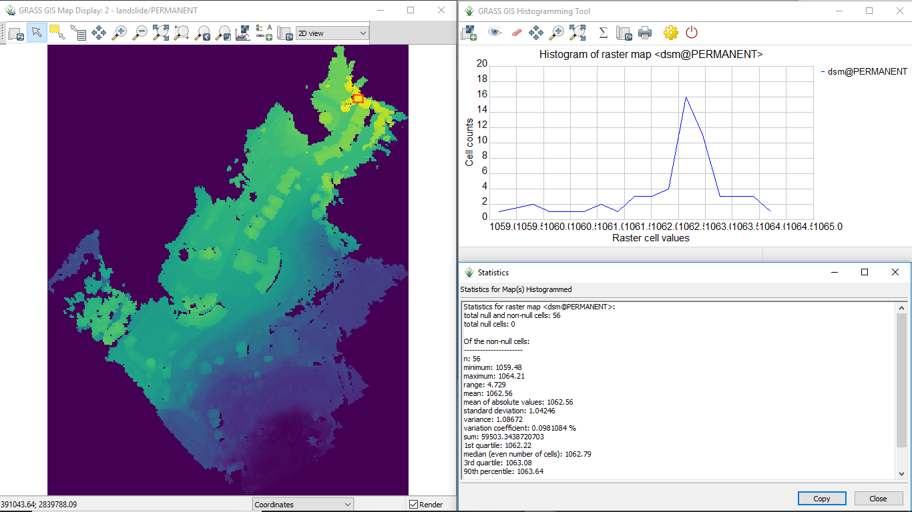

Figure 3.1: Digital Surface Model (DSM)

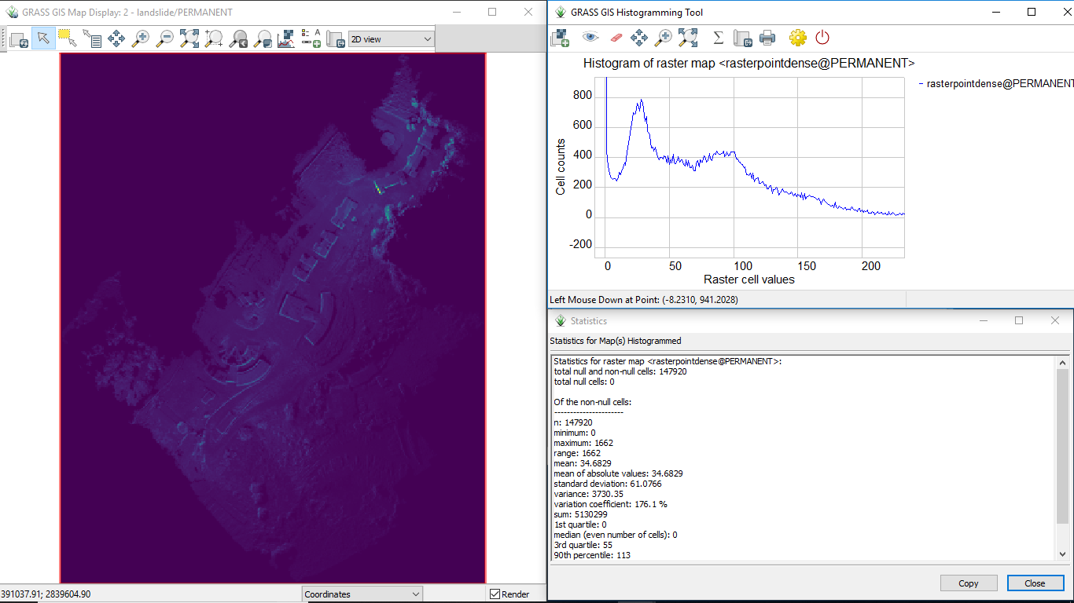

Figure3.2: various statistical information of the model can be represented.

Point cloud is either binned into a raster (e.g. r.in.lidar) or then analyzed as raster or optionally decimated (e.g. using v.in.lidar) converted to vector (still using v.in.lidar) and then interpolated (e.g. v.surf.rst) into raster or analyzed as a vector. In this way the raster and vector data are analyzed. Method like n is used in r.in.lidar to find the number of points in the cell. Before interpolating, the spatial distribution of the points is confirmed.

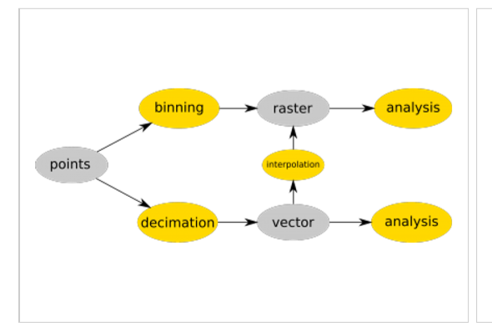

Figure 3.3: workflow in GRASS GIS

Small portions of orthophoto can be analyzed by computing the statistical data and histograms of the portions by using the certain tools available in GRASS GIS. In the following orthophoto two sections are selected to do the above. From this, we can observe the number of points per cell, density of the points etc. This let us to know the contribution of points in the 3D structure. 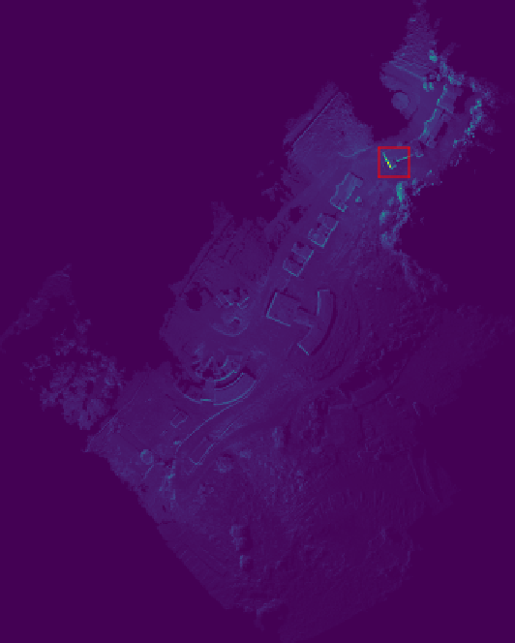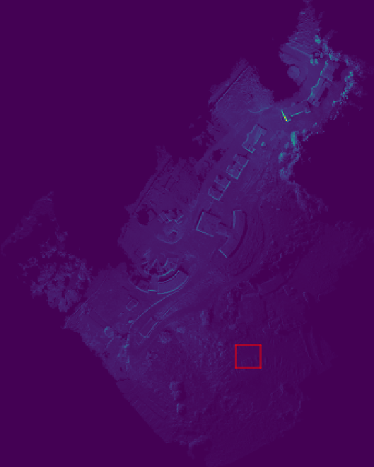

Figure 3.4: portion A Figure 3.5: portion B

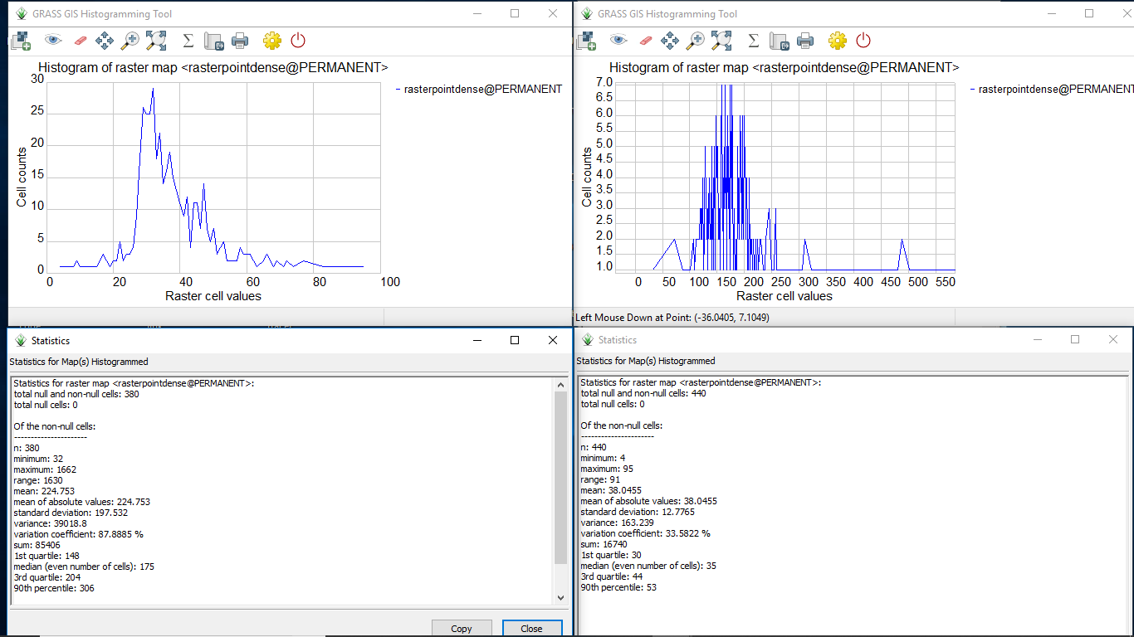

Figure 3.6: Statistical data comparison of both the portions of figure 3.4 and figure 3.5



Figure 3.7: Ortho view of the Digital analysis of the selected portion surface model with the statistical

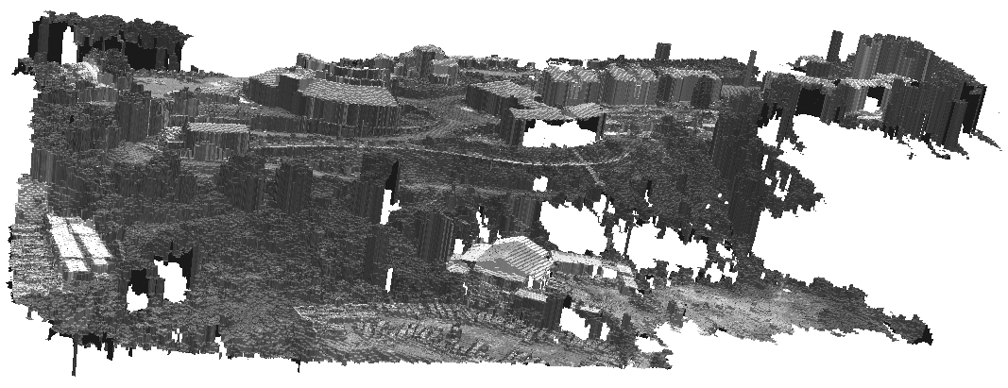 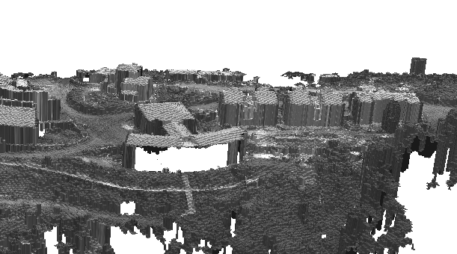

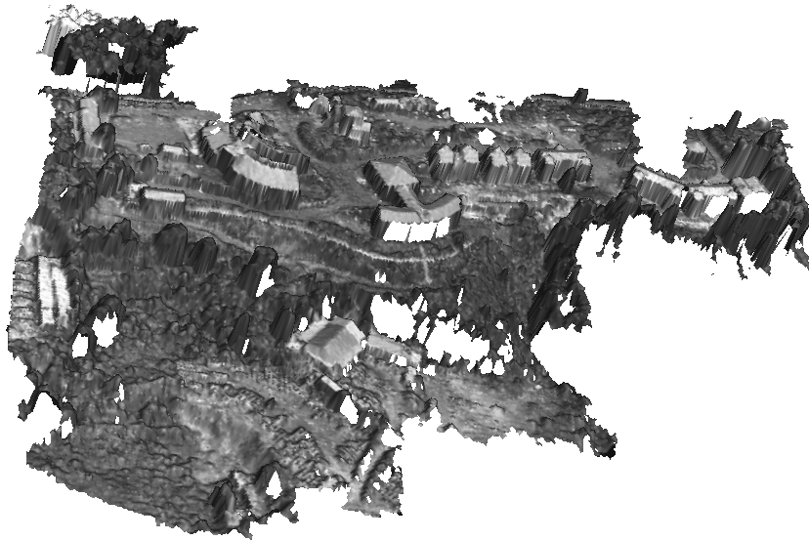

Figure 3.8: 3D view of the formed DSM

**Chapter 4**

**Analysis of the 3D point clouds**

**4.1 Point cloud analysis**

Point clouds acquired from terrestrial or airborne sensors are one of the major data sources for retrieving semantic information about our environment. After the process of 3 dimensional point clouds generation is complete and we have the 3 dimensional point clouds it is very important that we do further analysis of the point cloud to derive relevant information from the point cloud. The analysis mainly involves understanding the variation in the characteristics of the points in the point cloud and segmenting the points based upon them and then further classifying them by putting proper labels on them. We have tried to classify the point cloud into various classes based on various characteristics. Analyzing the 3D point cloud to pick important attributes from the 3D data obtained involves two processes called segmentation and classification.

Segmentation involves the process of grouping of the point cloud into certain number of homogeneous segments based upon certain key traits which characterizes the segments. What we want to achieve is points from the point cloud to be under the same group so that classification can be done between sections of the point cloud which helps in its analysis.

Classification involves labeling the segmented groups produced in the segmentation process. This process provides semantics to the segmented groups. Therefore point cloud classification is often called semantic segmentation or point labeling. In this process the decision is made that onto which group the point tested will be a part of.

**4.2 Segmentation of 3D point cloud**

It is the process of grouping of the point cloud into homogeneous segments based upon some speciﬁc attributes. Segmentation is done based upon certain properties of the points in the point cloud. Certain attributes are elementary geometrical primitives, shape, size, orientation, colors, multispectral and thermal information. There are various segmentation methods and corresponding algorithms that are used for the purpose of segmentation. They are:

1. Edge based segmentation

2. Region growing segmentation

3. Segmentation by model ﬁtting

4. Hybrid segmentation technique

5. Machine learning segmentation

The machine learning segmentation can be done through two ways they are: a. Segmentation using K-means clustering b. Segmentation based on hierarchical clustering.

**4.2.1. Edge based segmentation:**

Edge based segmentation involves segmentation based on the boundaries of object. The edges are characterized by the object boundaries, texture and variation in surface orientation. Segmentation based on edge involves two steps, they are:

(a). Edge detection to create the outline of the regions detected.

(b). Grouping of points within the boundaries so as to form the ﬁnal segments.

In the ﬁrst step of the segmentation process edges are detected and as said earlier the variation of various attributes are maximum in the neighborhood of the edge. Some of the attributes based on which edges can be detected are: normal, gradient, principal curvature, higher order derivatives and also a large variation in the grey value of the points in the surrounding of the edges are visible.

Some methods or attributes are used as follows:

Gradient: The gradient method detects the edges by looking for the maximum and minimum in the ﬁrst derivative of the image. Sharp edges can be separated out by appropriate thresholding.

Laplacian: The Laplacian method searches for zero crossings in the second derivative of the image to ﬁnd edges. After the detection is done the segments are formed by clustering the points with similar attributes to form the ﬁnal segments. However, they may produce not accurate results in case of noise and uneven density of point clouds, situations that commonly occur in point cloud data.

**4.2.2. Region growing segmentation**:

Region Growing Segmentation involves selection of one or more points, called the seed points in the point cloud based on certain attributes and analyzing the neighboring points based on the characteristics and adding into the same group if the attributes are similar. A seed point is the lowest point in the rasterised point cloud ,also can be deﬁned as the initial point that is considered to be the base point to search for a particular attribute and form the cluster. The various attributes based on which growing of region is done are surface orientation, curvature etc.

Region based methods can be classiﬁed into two forms:

**(a). Bottoms- up approach:**

It starts by taking one seed point and grow the segment by adding more points, on the basis of same criteria as the seed point is selected with some threshold value. Selection of the seed point is a key to the success of this method as inaccurate selection of the seed points will result in under segmented or over segmented of the point cloud. Recently graph representations of images are used where the pixels are considered as the node and the links between them represent the relation between them. A common way to form the segments is to partition the graphs into subset corresponding to salient image region that is regions with some speciﬁc traits. A hierarchical graph is used to show the segmented regions and the relation between them. The segmentation take into account attributes like texture, average intensity and boundary properties of the image region. The bottoms-up approach is done in a successive and recursive way. That is segmentation is applies successive and recursive coarsening due to which at each level the area of homogeneous segments increases. Thus as the process continues the volume of each segment increases and also the number of segments thereby giving speciﬁc features for image segmentation. While segmenting into various segments a segmentation weighted hierarchical graph is created in which each segment placed in any coarse level is connected to another segment through a weight. Within a single level of the hierarchical graph the weights shows the similarities in the segments. The bottoms-up approach also comes with algorithms which give the measure of the saliency which accounts for the distinctness of the segment, given by an energy measure Гi that is described as the segment dissimilarities with its surrounding divided by its internal homogeneity. Similarity of the segment with its surrounding gives a high value of Гi and if the there is a large dissimilarity of the segment with the neighboring and a high level of homogeneity within the segment it will give us a low value of the energy measure Гi. The purpose of the algorithm is to merge**/**join similar points and deliver a set of clusters with points belonging to the same smooth surface.

However, these methods are sensitive to (i) the location of initial seed regions and (ii) inaccurate estimations of the normals and curvatures of points near region boundaries.

**(b) Top down approach:**

This approach uses object representation learned from examples to detect an object in a given input image and provide an approximation to its ﬁgure-ground segmentation. Figure-ground segmentation is derived from the concept of ﬁgure ground perception, which is a type of perception grouping .perceptual process is the process of determining which region and parts of the visual scene belong together as a part of higher order perceptual unit, i.e. it separates an object from its background in an image. Top down approach for segmentation needs to acquire data which are class speciﬁc information that is it is a collection of information or in this case collection of image patches which are similar enough to be under the same class. These classes are then used to identify features in an image of speciﬁc class. In the segmentation process the images in the class are used as primitives for the class. When segmentation of objects in a new image is to be done, the objects in the new images are tried to be covered by images patches used as primitives from the speciﬁc classes.

The top down approach of group growing segmentation has two steps that are need to be followed.

The ﬁrst steps involves training which consist of construction of a set of informative image fragment from the training data to capture the possible variability in shape and orientation and the overall look of the object in a given class.

The second step involves selecting a set of fragments from the speciﬁc class such that on the segmentation process these fragments can be used for the easy detection of the features, the approximate location and scaling of the corresponding object. The region based segmentation basically includes two steps:

1. Identiﬁcation of the seed points, which is done based on the curvature of each point.

2. Growing these points by adding new vertices into them based on the same predeﬁned criterion that are used for the key point, such as proximity of the two point and planarity of surfaces. Attributes like color can also be used for this purpose. However using growing region segmentation has some drawbacks and can be describes as follows: these methods are sensitive to-

(i) The location of initial seed regions and

(ii) Inaccurate estimations of the normals and curvatures of points near region boundaries.

**4.2.3. Hybrid segmentation techniques:**

The hybrid segmentation technique uses a number of algorithms together in order to enhance the strength of certain algorithm along with overcoming the weaknesses of certain algorithms. Hybrid segmentation combines the edge-based and region based growth methods by ﬁnding the diﬀerential information of the point neighborhood and by using the obtained diﬀerential information to identify the boundary points or boundary curves

**4.2.4. Segmentation using model ﬁtting:**

This method involves the decomposition of the objects into primitive shapes like cylinder, sphere and planes etc. The shapes are adjusted into the point cloud of the structures, those that agree the mathematical representation of the primitive shapes are considered as segments i.e. they resemble a particular shape. Model ﬁtting is based upon two basic algorithms:

**(a). Hough Transform:**

This algorithm earlier was used to detect the lines of an image. Later developed to detect other shapes like circles, ellipses. The simplest case of Hough transform is detecting straight lines. In general, the straight line y = m*x + c can be represented as a point (b, m) in the parameter space. However, vertical lines pose a problem. They would give rise to unbounded values of the slope parameter m so the use of the Hesse normal form is applied. r = x cos + y sin Where r is the distance of the origin to the closest point in the line, and is the angle between the x axis and the line connecting the origin with the close point.

The algorithm uses a two dimensional array known as an accumulator with dimension equal to two i.e. the number of unknown parameters, r and . A pixel in the image is considered (x, y) where Hough transform is applied to search for more points that can make up an edge or line. Then the parameters r and of that line is stored in a bin. The algorithm is continued for more lines and the value of the bin is incremented. Thus, Hough Transform results to a matrix where one dimension represents the slope of the perpendicular to the line and the other dimension represents the distance i.e. r. Each element in the matrix represents a value equal to the sum of the points on the line represented by parameters r and slope of the perpendicular to the line i.e. θ. So the element with highest value indicates the straight line that is most represented in the image. Similarly for circle detection we have Circular Hough Transform.

• Firstly an accumulator space is created which is a 3D matrix, and it is initialized by zero. A circle in 2 D is described as

$${\left(x-a\right)}^{2}+ {\left(y-b\right)}^{2}= r^{2}$$

Where (a, b) is the centre of the circle, and r is the radius.

If a 2D point (x, y) is ﬁxed, then the parameters can be found. The parameter space would be three dimensional, (a, b, r). And all the parameters that satisfy (x, y) would lie on the surface of an inverted right-angled cone whose apex is at (x, y, 0). In the 3D space, the circle parameters can be identiﬁed by the intersection of many conic surfaces that are deﬁned by points on the 2D circle.

This process can be divided into two stages.

(a) The ﬁrst stage is ﬁxing radius then ﬁnd the optimal centre of circles in a 2D parameter space.

(b) The second stage is to ﬁnd the optimal radius in a one dimensional parameter space.

**(b) RANSAC (Random Sample Consensus):**

RANSAC is the abbreviation of Random Sample Consensus. It is a general algorithm that can be used with other parameter estimation methods in order to obtain robust models with a certain probability when the noise in the data doesn’t obey the general noise assumption.

The RANSAC algorithm is essentially composed of two steps that are iteratively repeated:

1. In the ﬁrst step, a sample subset containing minimal data items is randomly selected from the input dataset. A ﬁtting model and the corresponding model parameters are computed using only the elements of this sample subset. The cardinality of the sample subset is the smallest suﬃcient to determine the model parameters.

2. In the second step, the algorithm checks which elements of the entire dataset are consistent with the model instantiated by the estimated model parameters obtained from the ﬁrst step. A data element will be considered as an outlier if it does not ﬁt the ﬁtting model instantiated by the set of estimated model parameters

ﬁgure: data set with outliers before applying RANSAC algorithm

ﬁgure: data set without outliers after applying RANSAC algorithm.

**4.2.5: Machine learning segmentation:**

Some segmentation algorithms are based on machine learning methods, such as hierarchical clustering, K-means or mean shift. Machine learning including deep learning, neural network, etc. is a scientiﬁc discipline concerned with the design and development of Artiﬁcial Intelligence algorithms that allow computers to take decisions based on empirical and training data. A learner can take advantage of examples (data) to capture and infer characteristics of interest of their unknown underlying probability distribution. This can be used in a wide way to segment points in a point cloud. There are two different approaches in machine learning. Those are supervised machine learning and unsupervised machine learning techniques that can be used with merits and demerits in each of them.

**4.3 Classification of 3D point cloud**

The key importance of segmenting the data points into various sections is so that different classes can be identified separately. Classification refers to the process of labeling the segmented sections of the point cloud. Classification is done after the segmentation of the point cloud is done in order to put some semantics into the groups formed. It helps us to derive information about the 3 dimensional models. Point cloud classification is also known as semantic segmentation and point classification.

The classification or class labeling process can be undertaken through three approaches.

**(a) Supervised approach:** in the supervised approach past data about the class is provided which is called the train data. The train data is a labeled set of data based on which various models are created. Based on the semantics that the data provide the points in the point cloud are classified into groups. However one prerequisite of this process is that a large training data is required to make up the high precision label and address the variability in the real world.

**(b) Unsupervised approach:** in the unsupervised approach based on the parameters on which classification is to be made the algorithm itself classify the data into various groups. The parameters are set by the user based on which partitioning is to be done. The best part about this approach is that it reduces the tedious work of creating the train data. However the quality of classification can be sacrificed.

**(c) Interactive approach:** in it the user is actively involved in the segmentation classiﬁcation loop by guiding the extraction of segments via feedback signals. This requires a large eﬀort from the user side but it could adapt and improve the segmentation result based on the user’s feedback.

**4.4 Machine learning as a tool for point cloud analysis**

Point cloud analysis involves understanding the various characteristics of the point cloud and analyzing the variations in the traits. For this the most necessary step is to understand the point data in the point cloud. In the due course of our research we are using point clouds generated from photogrammetry techniques. The point cloud generated via photogrammetry and further processing with structure from motion (SFM) and multi view stereo (MVS) algorithms has six parameters that accounts for their various traits. Thus the first three parameters account for the structure of the subject and the next three describes the appearance. The main goal of the process is to be able to classify the point cloud into various segments and acquire important information from them. Now it is a difficult job to do these by producing a hardcode as it should keep into account the various exceptions and variations that would be encountered while studying the point cloud. In such a situation machine learning can be of great use.

Machine learning is a subset of artificial intelligence and is the study of algorithms and statistical models that a computer system uses to predict solution to problems without providing explicit instruction. A machine learning algorithm creates a mathematical model based upon the sample data that is used. This data based on which the models is prepared is called the training data. Based on the data provided, predictions are made by the model without being explicitly programmed for the task. Certain machine learning approaches are also used to segment the data without actually providing training data beforehand to produce a model. Algorithms like K-means clustering technique is used to form clusters of points from the dataset in a way such that similar points fall under the same cluster and thus the data can be classified. Based on whether training of the model with training data is involved or not the machine learning approach can be divided into supervised and unsupervised machine learning approach.

**4.4.1 Unsupervised machine learning**

In unsupervised approach of machine learning the data that is provided for the training of the machine is not classified into classes manually but the algorithm decides the number of classes the data is to be divided. The algorithms take into account the parameters set by the user and classify the data into certain number of segments.

K means clustering technique is an unsupervised machine learning algorithm which divides the data points into clusters based on the relative distances of the points. We have used this algorithm to form clusters of the point cloud in order to obtain segments with differing characters. The number of clusters that would be formed would be entirely based upon the algorithm itself. In K means by using the elbow method we can analyze what number of clusters that would be optimum for the data. K means is a strong algorithm when the differences between the point data in their characteristics are very prominent and distinct.

**4.4.2 Supervised machine learning**

In supervised machine learning technique a set of labeled data is used to create a mathematical model based on which predictions about the solution is made. The model that is formed is based on the various semantics derived from the data used. Thus proper labeling of the data that is fed into to create the model is very important aspect of supervised machine learning. Unlike unsupervised machine learning techniques the number of groups or segments or clusters that would be formed is known beforehand as the labeling is done prior to the classification. Parameters from the train data that are taken for creating the model is of key importance. Thus proper analysis of the data is required which is quite a tedious task to accomplish. In the due course of our research we have created various classes of test data which are tested and proper analysis of the model is done in a detail manner.

Binary logistic regression is a supervised machine learning classification algorithm which can classify a data set into two sub sets based upon certain traits. Binary logistic regression is closely related with linear regression as the hypothesis function of linear regression is fed into the sigmoid function to get the hypothesis function of logistic regression.

**4.5 K means clustering for point cloud segmentation**

K-means clustering is a simple unsupervised learning algorithm that is used to solve clustering problems. It follows a simple procedure of classifying a given data set into a number of clusters, defined by the letter "k". The data on which clustering is done is an unlabelled set of data. As far as unsupervised approach is concern, the number of clusters that are to be made is not known and the algorithm finds a way for that, but however in K means clustering the k is set by the user. The optimum numbers of clusters that are to be formed are found by using the elbow method. The elbow method is a way of finding the optimum number of clusters for a particular data set. For this a plot between various values of clusters on the x axis and the sum of square errors on the y axis is made. It is observed that for a particular value of number of cluster there is a drastic decrease in the sum of square error and after that the decrease is very limited. The cluster corresponding to the high initial decrease is selected as the k for the dataset.

After the numbers of clusters are chosen K numbers of points in the dataset are selected so that initial clustering can be done. The clusters are then positioned as points and all observations or data points are associated with the nearest cluster, computed, adjusted and then the process starts over using the new adjustments until a desired result is reached.

**The algorithm:**

1. K points are placed into the object data space representing the initial group of centroids.

2. Each object or data point is assigned into the closest k.

3. After all the data points are assign, the positions of the k centroids are recalculated.

4. Steps 2 and 3 are repeated until the positions of the centroids no longer move.

K-means clustering has uses in search engines, market segmentation, statistics and even astronomy.

**4.5.1. Objective**

By using K means clustering technique, which is an unsupervised method we obviously want to reduce the human effort in preparing the labeled data. Further we want to acquire information about how will the algorithm perform in clustering the point cloud when there is large variations within a single class of the point cloud and when the classes of the point cloud are relatively homogeneous. So accuracy of the model would also be kept into note.

**4.5.2. Methodology**

While analyzing the data for further segmentation and then later classification, K means can be a use as a useful tool to segment the data which can be later on labeled. First of all we analyze the data that would be fed into the algorithm.

We have produced point clouds which have been produced from the photogrammetric approach. Thus, even though the data has 16 parameters only 6 out of it are usable. The six parameters on the basis of which we are analyzing the point cloud are X, Y, Z coordinate of the points and ‘red’, ‘green’ and ‘blue’ value in the grayscale. The X, Y and Z coordinate describes the positions of the points in the 3 dimensional space. And the other three parameters give the information about the coloration of the points. Based on various combinations of these parameters we have applied the K means algorithm on the data to obtain proper segmentation of the point cloud.

The dataset that we are considering to test this algorithm is a point cloud which contains group of points representing sections of ground, vegetations and man-made structures. To implement the algorithm we have used Python3 as the platform to program for the model. The lone reason of choosing Python3 is due to its ease of use.

Some statistics about the data is given below:

|  |  |
| --- | --- |
| Parameters | Value |
| N | 5130299 |
| Xmin | 390656.594 |
| Xmax | 390999.72 |
| Ymin | 2839367.402 |
| Ymax | 2839796.064 |
| Zmin | 983.865 |
| Zmax | 1064.525 |
| Zmean | 1028.087 |
| Rmin | 2304.0 |
| Rmax | 65280.0 |
| Bmin | 0.0 |
| Bmax | 65280.0 |
| Gmin | 3328.0 |
| Gmax | 65280.0 |

Where,

N gives the total number of samples in the point cloud Xmin gives the minimum value of X coordinate; Xmax gives the maximum value of X coordinate; Ymin gives the minimum value of Y coordinate; Ymax gives the maximum value of Y coordinate; Zmin gives the minimum value of Z coordinate; Zmax gives the maximum value of Z coordinate; Zmean gives the mean value of Z coordinate; Rmin gives the minimum value of red; Rmax gives the maximum value of red; Bmin gives the minimum value of blue; Bmax gives the maximum value of blue; Gmin gives the minimum value of green; Gmax gives the maximum value of green;

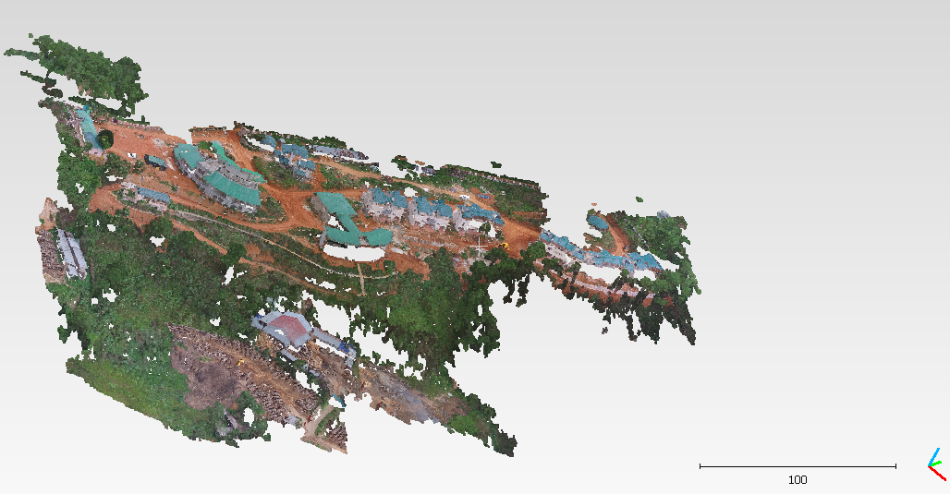

Figure 3.1: The original point cloud we are going to classify

Out of the six parameters we have used 3 parameters to create the model to segment the point cloud. Those parameters are the value of Red, Blue and Green.

The reason of not choosing the other parameters for the process is that X and Y parameters do not offer any semantics to decide between class and the Z value have a wide variation and on close observation of the point cloud it turned evident that the area of which point clouds are formed is highly irregular in terms of its altitude so using Z as a parameter in the model formation process will yield noise.

To implement the algorithm we have used python 3 as the platform to program for the model. The lone reason of choosing python 3 is due to its ease of use. Python3 contains various built in libraries which contain functions for the implementation of these algorithms. Libraries like sklearn, pandas, numpy have been used in the code.

We have passed the point cloud through two cycles of clustering in order to obtain a better precision.

First of all we found the value of k that would be optimum by using the elbow method, which turned out to be 2 for the dataset.

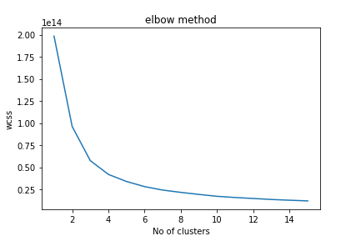

Figure: using elbow method number of optimum clusters is calculated.

The point cloud that we are testing is in .las format so to process it using functions in python we have to convert the format into .csv. For this we have used the PDAL’s (Point Data Abstraction Library) translate function which have created a csv file of given name. The command has been run in anaconda prompt.



This gives us a .csv file which is passed through the code for further segmentation. For the first clustering a dataframe of the initial .csv file is created by using the pandas library and k means clustering is used to segment the dataframe into two new dataframe. The two formed dataframes are then passed through the same clustering algorithms to produce two more dataframes from each one of them. Thus we have four clusters from the second cycle of clustering and all together we have six clusters. After the clusters are formed each of the dataframes are then converted into .csv file. We can again convert the .csv files so generated into .las file so that we can visualize the data in the form of separated point clouds.

The workflow for our approach is given by:

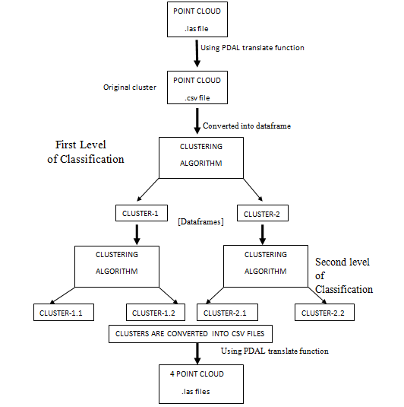

**4.5.3. Our observations**

Initially we have the dataset which is necessarily a point cloud of an area which contains portions of vegetation, road, soil and buildings. After the first cycle of clustering is done we obtain two point clouds.

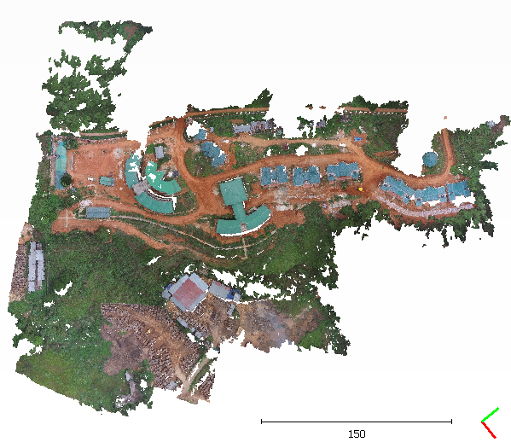

Figure 3.2: The point cloud before segmentation.

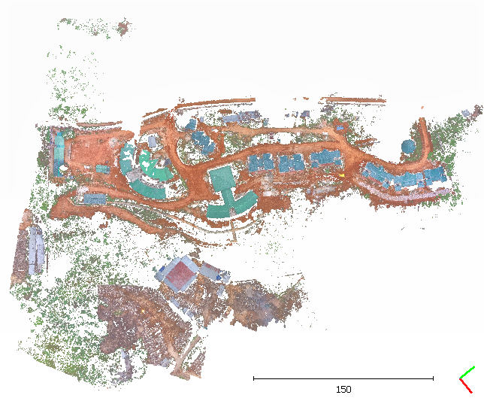 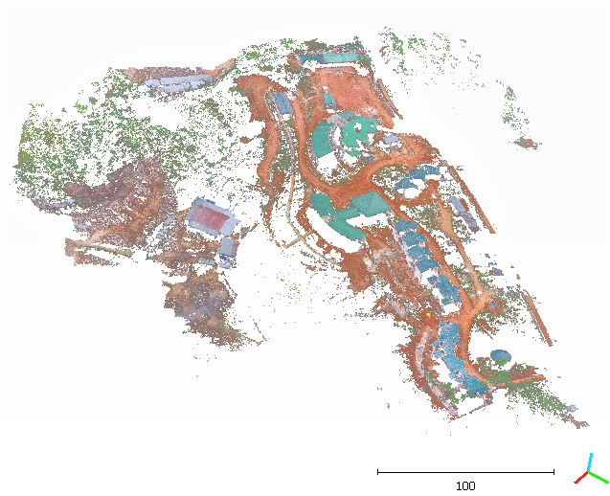

Figure 3.3: Cluster-1.

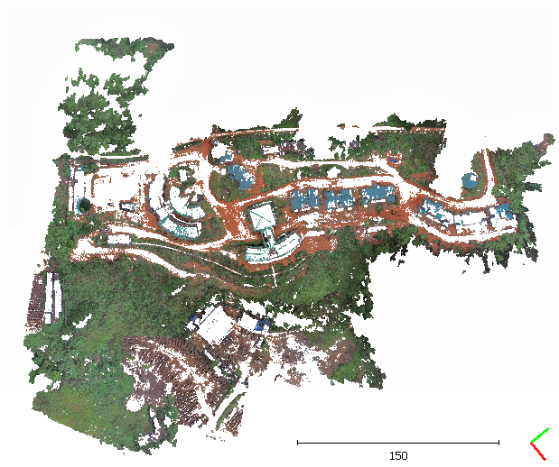 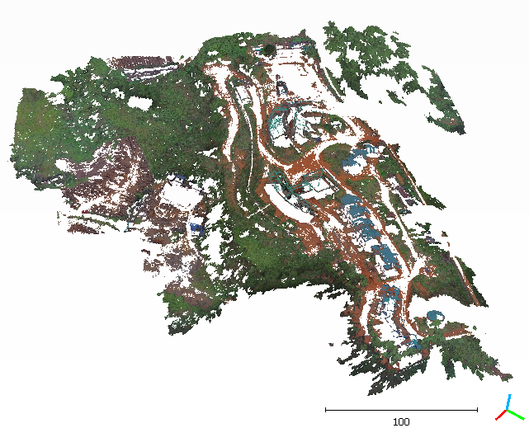

Figure 3.4: Cluster-2.

Some statistics on our observation after the first level of clustering are given below:

|  |  |  |  |
| --- | --- | --- | --- |
| parameters | Original  data set | Cluster-1 | Cluster-2 |
| N | 5130299 | 2901495 | 2228804 |
| Xmin | 390656.594 | 390656.594 | 390656.924 |
| Xmax | 390999.72 | 390999.72 | 390995.843 |
| Ymin | 2839367.402 | 2839367.402 | 2839367.523 |
| Ymax | 2839796.064 | 2839796.064 | 2839795.866 |
| Zmin | 983.865 | 983.865 | 984.007 |
| Zmax | 1064.525 | 1064.525 | 1064.399 |
| Zmean | 1028.087 | 1025.735 | 1031.148 |
| Rmin | 2304.0 | 2304.0 | 7680.0 |
| Rmax | 65280.0 | 50944.0 | 65280.0 |
| Gmin | 3328.0 | 3328.0 | 11008.0 |
| Gmax | 65280.0 | 38144.0 | 65280.0 |
| Bmin | 0.0 | 0.0 | 6912.0 |
| Bmax | 65280.0 | 44032.0 | 65280.0 |

Table 3.1: comparison between the clusters formed at the first level of clustering

After the first cycle of clustering is done the next level of clustering produces four more clusters. Two cluster from Cluster-1 and two from Cluster-2.

Clustering the Cluster-1 into two more clusters we obtain cluster-1.1 and cluster-1.2

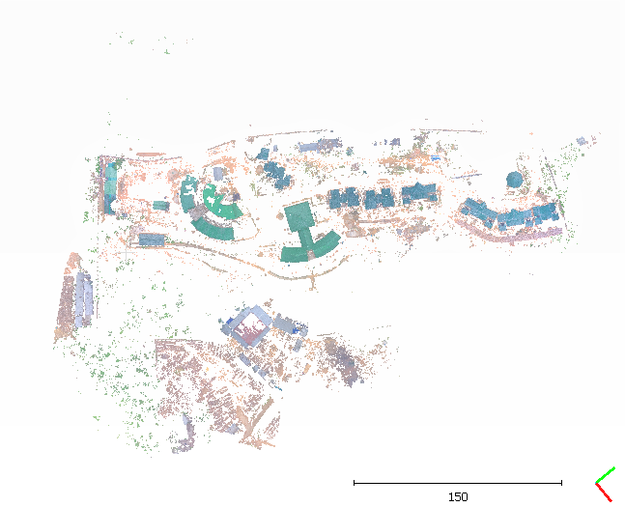 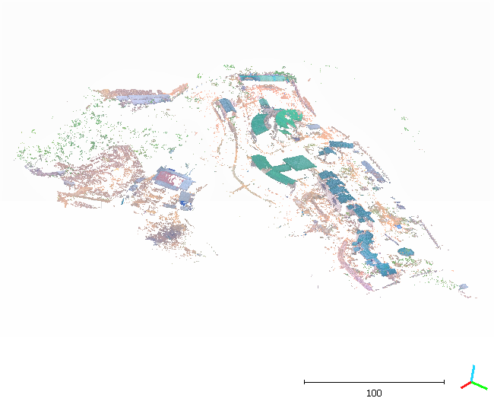

Figure 3.5: Cluster-1.1

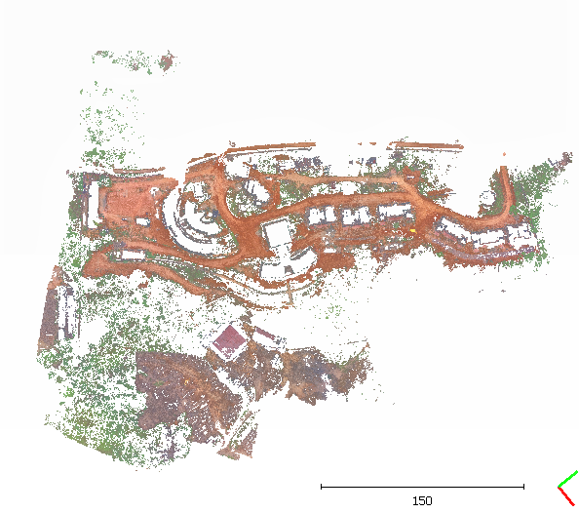 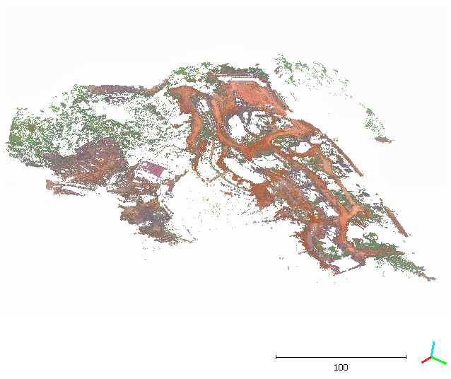

Figure 3.6: Cluster-1.2

Clustering the Cluster-2 into two more clusters we obtain cluster-2.1 and cluster-2.2

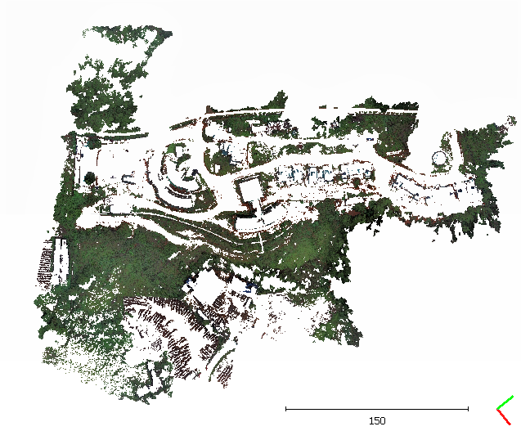 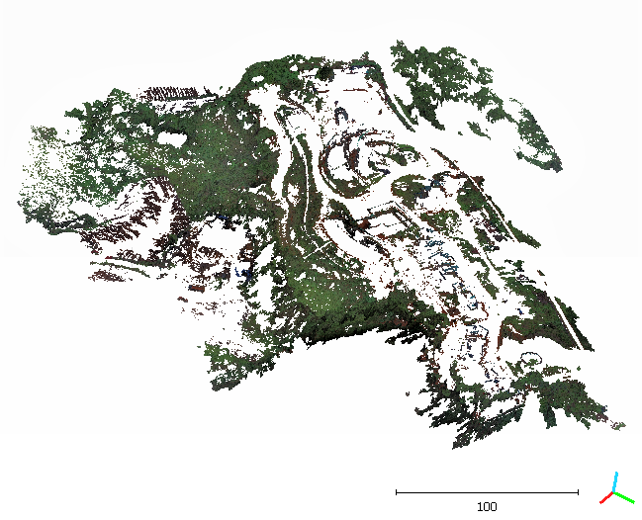

Figure 3.7: Cluster 2.1

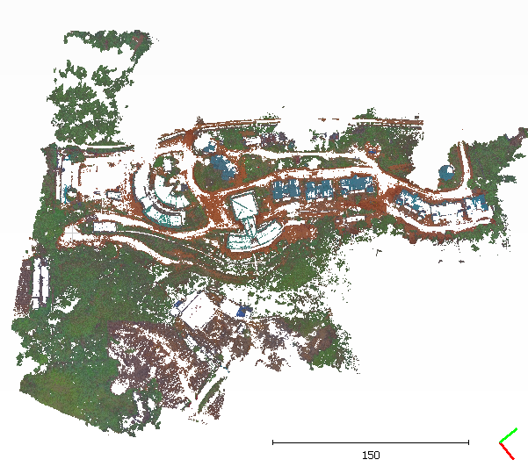 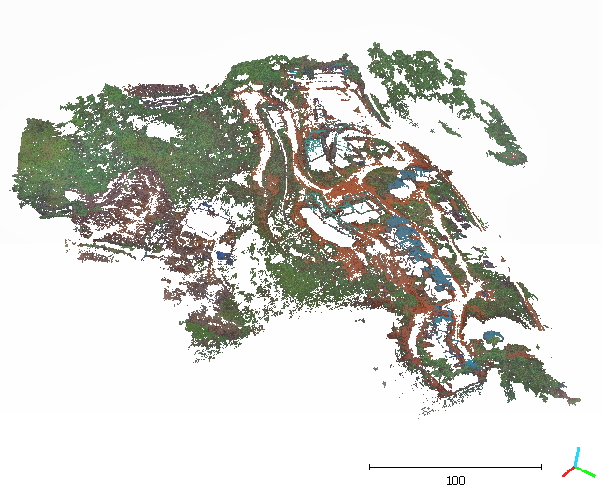

Figure 3.8: Cluster 2.2

Some statistics on our observation after the second level of clustering are given below.

|  |  |  |  |  |
| --- | --- | --- | --- | --- |
| Parameters | Cluster-1.1 | Cluster-1.2 | Cluster-2.1 | Cluster-2.2 |
| N | 883288 | 1345516 | 1452129 | 1449366 |
| Xmin | 390658.633 | 390656.924 | 390657.194 | 390656.594 |
| Xmax | 390985.151 | 390995.843 | 390999.72 | 390999.393 |
| Ymin | 2839380.229 | 2839367.523 | 2839368.06 | 2839367.402 |
| Ymax | 2839795.495 | 2839795.866 | 2839796.064 | 2839795.998 |
| Zmin | 984.257 | 984.007 | 983.902 | 983.865 |
| Zmax | 1063.721 | 1064.399 | 1064.284 | 1064.525 |
| Zmean | 1035.207 | 1028.484 | 1025.411 | 1026.060 |
| Rmin | 7680.0 | 22784.0 | 2304.0 | 3840.0 |
| Rmax | 65280.0 | 65280.0 | 31232.0 | 50944.0 |
| Gmin | 23552.0 | 11008.0 | 3328.0 | 7680.0 |
| Gmax | 65280.0 | 55808.0 | 30720.0 | 38144.0 |
| Bmin | 25344.0 | 6912.0 | 0.0 | 2048.0 |
| Bmax | 65280.0 | 38656.0 | 36864.0 | 44032.0 |

Table 3.2: comparison between the clusters formed at the second level of clustering

The comparison can also be shown in a graphical approach as the follows:

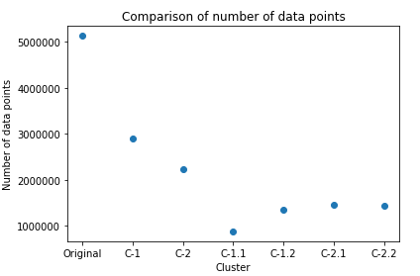 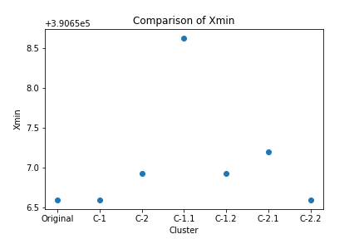

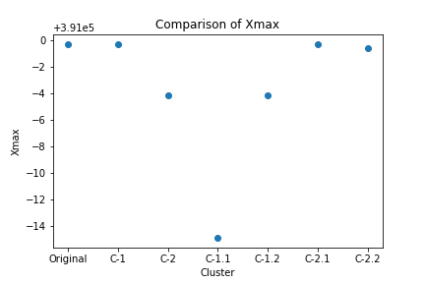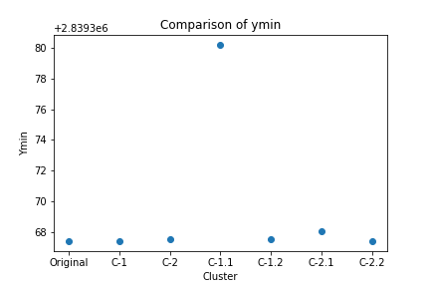

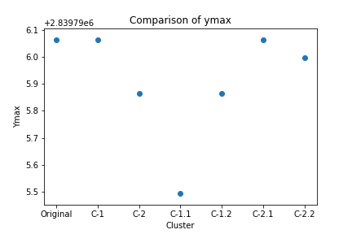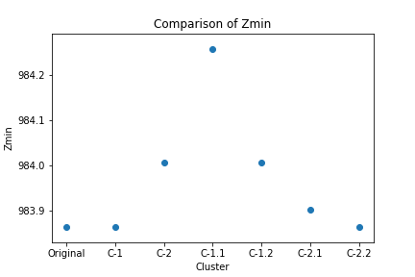

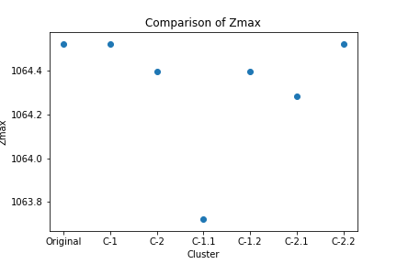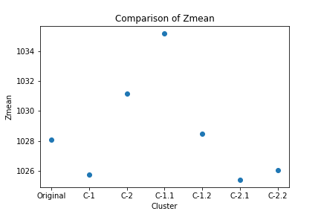

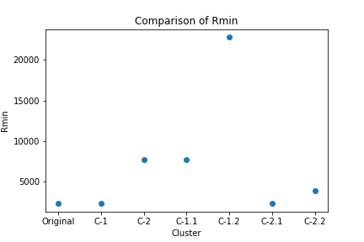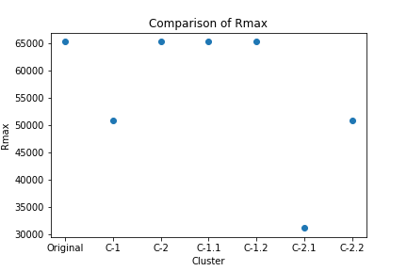

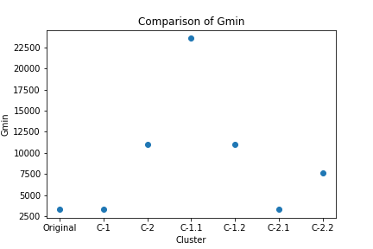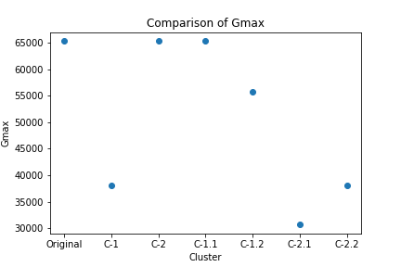

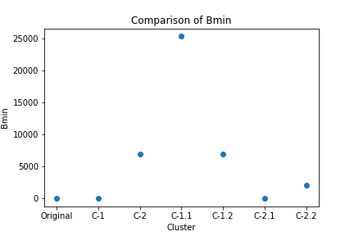 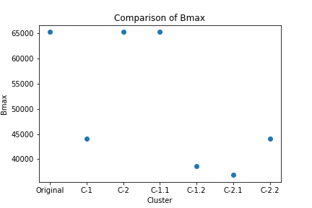

Figure 3.9: Graphical representation of the comparison between various parameters.

**4.5.4. Results**

From the outputs of the algorithm at the first clustering that is done on the dataset we can surely see some promising results as we can see that most of the areas with vegetation are separated from those areas without vegetation. But however on subsequent clustering the results that we obtained are not very remarkable. The clusters formed at the second level do not have clear cut characteristics that are visible, that they can be differentiated. For instances Cluster-2.1 and Cluster-2.2 almost have the same amount of vegetative area and there is no distinct parameter on which they vary such that, they can be pointed out by looking onto the formed Clusters. Further it is quite evident that on subsequent clustering the density of the point cloud is reduced and in return not much distinction between classes is achieved.

**4.5.5 Inference**

**Advantages:**

1. If variables are huge, then K-Means most of the times computationally faster than some other clustering methods, if we keep k smalls.
2. K-Means produce tighter clusters than hierarchical clustering, especially if the clusters are globular.
3. It is very useful when dataset have very less deviations (for example if dataset contains only two colors they can be easily separated using k-means clustering).

**Disadvantages:**

1. Difficult to predict K-Value. Generally point cloud datasets are too large. For predicting K-value by elbow method needs much iteration, which is very time consuming and need high computational power.
2. Different initial partitions can result in different final clusters.
3. It does not work well with clusters (in the original data) of different size and different density.

**4.6 Regression for point cloud analysis**

Regression is a predictive modeling technique. It estimates the relationship between a dependent that is the target variable and an independent variable or the predictor variable. The value along y-axis depends on the value along x-axis, hence named as dependent variable. The values along y-axis can be predicted using equation of straight line;

y= mx + c

Regression can be classified into three forms and they are Linear Regression, Logistic Regression and Polynomial Regression. In our research we are mainly focusing on the performance of logistic regression on the classification of point cloud.

Any form of regression depend the most on the data that is fed into it so a clear understanding of dataset and its various forms is of high significance. In the due course of our research we are considering to focus mainly on logistic regression as a part of supervised approach and functioning of it requires a good set of labeled data.

**Dataset**

A dataset is a collection of related, discrete items of related data that may be accessed individually or in combination or managed as a whole entity. A dataset is organized into some kind of data structure. In easy terms, dataset is a collection of data. A single database table can be referred as a dataset where every column of the table represents a particular variable and each row corresponds to a given member of the dataset taken. In the dataset table one can take attributes like height or weight or colors of an object or subject. Each value is known as a datum.

In our datasets there are various parameters like intensity, number of returns etc., we take the X, Y, Z coordinates or r, g, b values for analyzing. The values in the table are of same kind and in times missing values are faced in some of the places.

Any model that is formed must be tested so the dataset is divided into two forms, and those are training and test dataset.

**Training dataset**

The training dataset is a dataset which is used for training the model. The train dataset can contain anywhere from 60 - 80 percentage of the total dataset depending on the user and requirement while the remaining data is used for testing the efficiency of the model. The model is initially fit on a training dataset. The model is trained on the training dataset using a supervised learning method. The current model is running on a trained dataset and produces a result, which is then compared with the target, for each input vector in the training dataset.

**Validation dataset**

Successively, the fitted model is used to predict the responses for the observations in a second dataset called the validation dataset. While the training dataset is used to train the candidate algorithms, validation dataset is use to compare their performances and decide which one to take and finally the test dataset is obtained. Our main goal is to find the network having best performance on new data. The easiest approach is to evaluate the error function using data which is independent of that used for training. The performance of the networks is compared by evaluating the error function using an independent validation set and the particular network having the least error with respect to the validation set is selected. The performance of the selected network should be confirmed by measuring its performance on a third independent dataset called a test set.

**Test dataset**

A test dataset is a dataset that is independent of the training dataset but that follows the same probability distribution as the training dataset. The test dataset is used to check the performance characteristics such as accuracy, sensitivity, specificity, F-measure etc. If a model fit to the training dataset also fits the test dataset well, minimal over fitting has taken place.

**Holdout Dataset**

A part of the original dataset is taken for testing the model efficiency. This part is named as holdout dataset.

**Cross-validation**

Once we are done with training our model we just can't assume that it is going to work well on some unseen data. So in order to ensure the accuracy and variance of the model we need to validate our model.

Cross validation is one of the techniques used to test the effectiveness of a machine-learning model. In order to perform cross-validation there are many techniques like Train_Test Split approach or K-Folds Cross Validation etc. We applied the former technique for splitting up our dataset.

**Train_Test Split approach**

According to this approach we split the dataset into training and test sets with the help of scikit-learn method. With the help of training set we train the model and then use the test set for validation purpose. 70 percentage of the dataset is used for training while the rest is used for testing of the model.

**4.6.1. Logistic Regression**

Logistic Regression produces results in a binary format which is used to predict the outcome of a categorical dependent variable. So, the outcome should be discrete / categorical such as 0 or 1, Yes or No, True or False or High or Low.

The reason linear regression is not considered for the purpose is because in case of Linear Regression the values of y is in a range but we need only discrete y-values i.e. 0 or 1 which is favored by Logistic Regression. Here, we clipped off the values below 0 and above 1. Hence, we obtain a sigmoid(S) curve shown below (right)

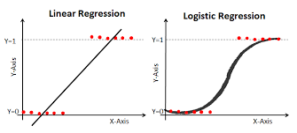

Figure 3.9: Comparison of graph of linear and logistic regression

In order to classify the points into two classes, we take a threshold value of 0.5. Then all the y-values above 0.5 will belong to 1 while all the values below 0.5 will belong to class corresponding to 0. In this way, we will classify the point data into two groups.

Mathematically, logistic regression equation is obtained from straight line equation. Equation of straight line is given by;

$$y = C + m1x1 + m2x2 +…$$

Where range is from -∞ to ∞.

Reducing Logistic Regression from straight line equation, we get,

$Y = C +m1x1 + m2x2 +...$

Where range is from 0 to 1

On transforming it further we get the range from -∞ to ∞.

$$\log\left[\frac{y}{\left(1-y\right)}\right]→ y= C + m1x1 + m2x2 + …,$$

Which is the Final Logistic Regression Equation.

**4.6.2. Objective**

Binary logistic regression is a method of classifying data points from a dataset into two classes. Thus using logistic regression involves creating pairs of labeled data for the various pairs of classes. This process of creating labeled data involves a tedious job of manually selecting the points that would belong to a particular class. This effort is being made to achieve relatively high amount of accuracy even in dataset that would have high variation among the same class provided such variations are taken into account while creating the labeled data.

**4.6.3. Methodology**

The entire process in which classification of the point cloud is done can be divided into five steps

●Firstly, collection of data.

● Analyzing Data

● Data Wrangling (Cleaning of unwanted data)

● Train and Test

● Accuracy Check

Initially we have a point cloud of the area that contains areas with roads, vegetations and buildings etc. that we have used to form various model to classify point cloud. To create two contrasting dataset at a time we have manually segmented each class form the point cloud using cloud compare, which is a open source platform of processing point cloud. The datasets that are the two point cloud that we will use for creating the model is initially in .las format. So the files are converted into .csv format so that it can be processed using python libraries. After the csv files are obtained they are made into dataframes and proper labeling of each class is done individually and then both the dataframes are merged together to form a single labeled dataset.

Some statistics about the formed data are as follows:

|  |  |
| --- | --- |
| Parameters | value |
| N | 5130299 |
| Xmin | 390656.594 |
| Xmax | 390999.72 |
| Ymin | 2839367.402 |
| Ymax | 2839796.064 |
| Zmin | 983.865 |
| Zmax | 1064.525 |
| Zmean | 1028.087 |
| Rmin | 2304.0 |
| Rmax | 65280.0 |
| Bmin | 0.0 |
| Bmax | 65280.0 |
| Gmin | 3328.0 |
| Gmax | 65280.0 |

Where,

N gives the total number of samples in the point cloud Xmin gives the minimum value of X coordinate; Xmax gives the maximum value of X coordinate; Ymin gives the minimum value of Y coordinate; Ymax gives the maximum value of Y coordinate; Zmin gives the minimum value of Z coordinate; Zmax gives the maximum value of Z coordinate; Zmean gives the mean value of Z coordinate; Rmin gives the minimum value of red; Rmax gives the maximum value of red; Bmin gives the minimum value of blue; Bmax gives the maximum value of blue; Gmin gives the minimum value of green; Gmax gives the maximum value of green;

Required libraries are imported and data is read from the csv file. The data part is analyzed and checked whether any null values are present in the dataset. While clearing of data, we try to remove all the NaN (not a number) values and unnecessary columns from the dataset. Instead of removing the null values we can also replace it by the mean value. The main dataset after its cleaning up is divided mainly into two parts. One part is the train part to prepare a model based on it. And the other part is the test part which is used to test the trained model. Later on, we checked the accuracy of the model by comparing the test values with the predicted values.

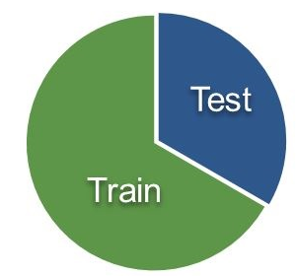

Figure 3.10: the division of the dataset to train and test the model.

**The workflow for the process is given as follows:**

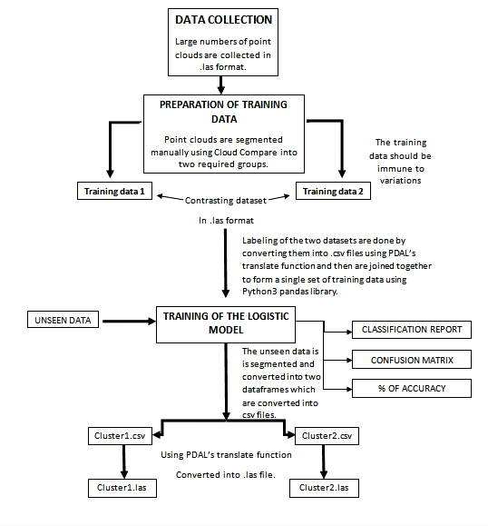

We have created three models for which different pairs of data are extracted. These pairs are

●Vegetative and non-vegetative areas

●Building and non-building areas

●Ground and non-ground areas

**Dataset 1: Vegetative and non-vegetative areas**

We have manually segmented the point cloud into two point clouds such that one of them contains points belonging to areas which contains and the other which is independent of such structures. To form the model for the classification out of all the parameters four of them are taken into account. Red, Green and Blue as well as Z coordinate. The Z coordinate provides some extra information about the height of the point which comes in handy when the task is to classify two points with similar coloration but different height.

Some statistics about the data are given as follows:

|  |  |  |
| --- | --- | --- |
| **Parameters** | **Non-vegetative** | **Vegetative** |
| N | 2849794 | 1914923 |
| Xmin | 390719.119 | 390656.594 |
| Xmax | 390979.892 | 390999.72 |
| Xmean | 390857.732 | 390851.879 |
| Ymin | 2839394.4 | 2839367.402 |
| Ymax | 2839794.536 | 2839796.064 |
| Ymean | 2839599.879 | 2839571.793 |
| Zmin | 984.15 | 983.865 |
| Zmax | 1061.531 | 1064.525 |
| Zmean | 1030.562 | 1023.359 |
| Rmin | 2816.0 | 2304.0 |
| Rmax | 65280.0 | 62464.0 |
| Bmin | 0.0 | 1536.0 |
| Bmax | 65280.0 | 63488.0 |
| Gmin | 3328.0 | 5376.0 |
| Gmax | 65280.0 | 64256.0 |

Table 3.3: comparison of the statistics from two contrasting training data

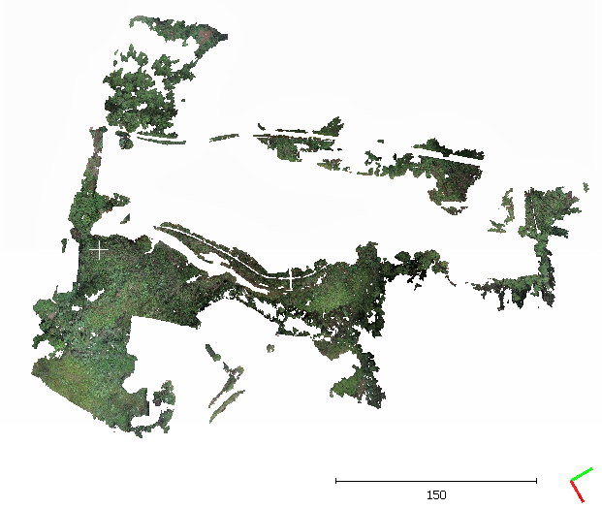 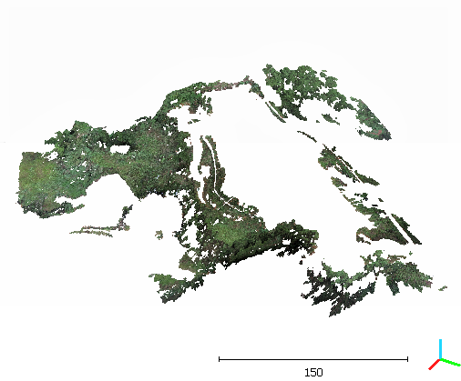

Figure 3.11: the point cloud containing only the areas with vegetation that is use to train the model

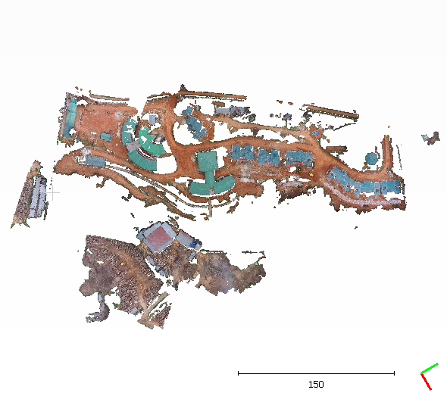 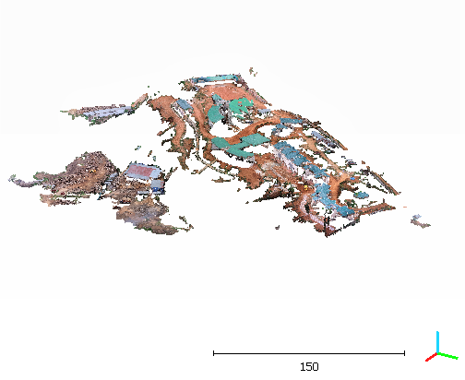

Figure 3.12: the point cloud containing only the areas without vegetation that is used to train the model

**Dataset 2: Building and non-building areas**

We have manually segmented the point cloud into two point clouds such that one of them contains points belonging to areas which contains buildings or any man-made construction and the other which is independent of such structures. To form the model for the classification out of all the parameters four of them are taken into account. Red, Green and Blue as well as Z coordinate. The Z coordinate provides some extra information about the height of the point which comes in handy when the task is to classify two points with similar colouration but different height.

Some statistics about the data are given as follows:

|  |  |  |
| --- | --- | --- |
| **Parameters** | **Non-building** | **Building** |
| N | 4159644 | 835199 |
| Xmin | 390656.594 | 390728.192 |
| Xmax | 390803.301 | 390999.012 |
| Xmean | 390760.385 | 390860.319 |
| Ymin | 2839395.902 | 2839415.325 |
| Ymax | 2839661.297 | 2839784.222 |
| Ymean | 2839519.929 | 2839609.721 |
| Zmin | 998.435 | 985.929 |
| Zmax | 1044.448 | 1052.408 |
| Zmean | 1026.183 | 1037.406 |
| Rmin | 2304.0 | 3072.0 |
| Rmax | 65024.0 | 65280.0 |
| Bmin | 1536.0 | 4096.0 |
| Bmax | 65280.0 | 65280.0 |
| Gmin | 4608.0 | 4352.0 |
| Gmax | 65024.0 | 65024.0 |

Table 3.4: comparison of the statistics from two contrasting training data

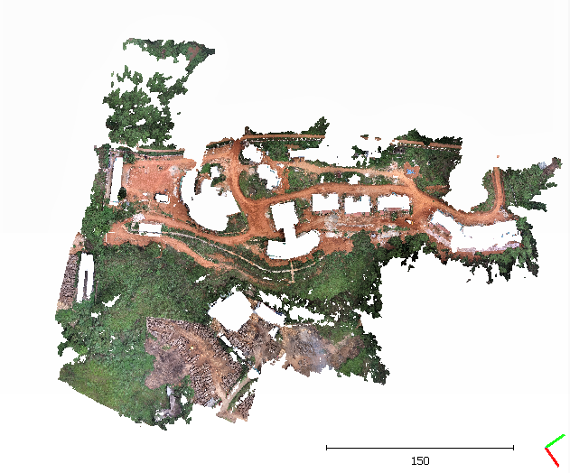 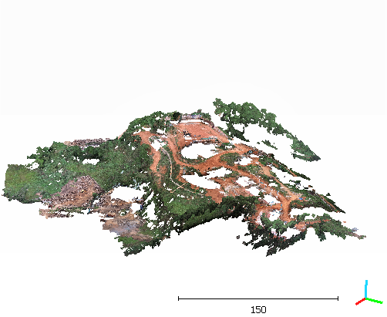

Figure 3.13: the point cloud containing only the areas with no building that is used to train the model

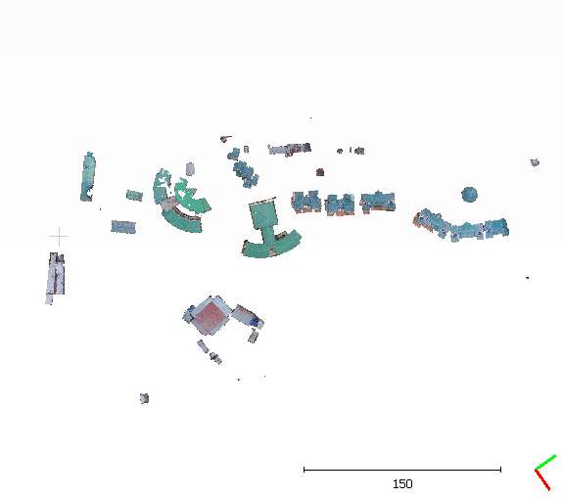 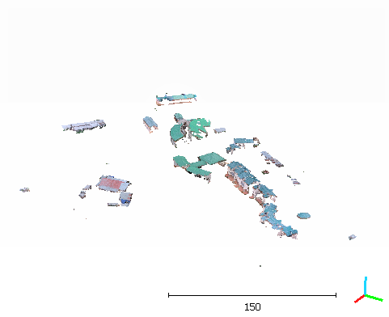

Figure 3.14: the point cloud containing only those areas with building that is used to train the model

**Dataset 3: Ground and non-ground areas**

We have manually segmented the point cloud into two point clouds such that one of them contains points belonging to areas with ground area and the other area contain non ground points. While forming the models the parameters that were taken into account were Z coordinate, Red, Green and Blue values of the points. The reason for X and the Y coordinate to being left out is as it only shows the span of the area and do not show any specific characteristics or pattern to follow on.

Some statistics about the data are given as follows:

|  |  |  |
| --- | --- | --- |
| **Parameters** | **ground** | **Non-ground** |
| Zmin | 983.865 | 983.868 |
| Zmax | 1047.395 | 1064.525 |
| Zmean | 1027.242 | 1028.987 |
| Rmin | 2816.0 | 2304.0 |
| Rmax | 65280.0 | 65280.0 |
| Gmin | 4352.0 | 3328.0 |
| Gmax | 65280.0 | 65820.0 |
| Bmin | 1536.0 | 1486.0 |
| Bmax | 65280.0 | 65820.0 |

Table 3.5: comparison of the statistics from two contrasting training data

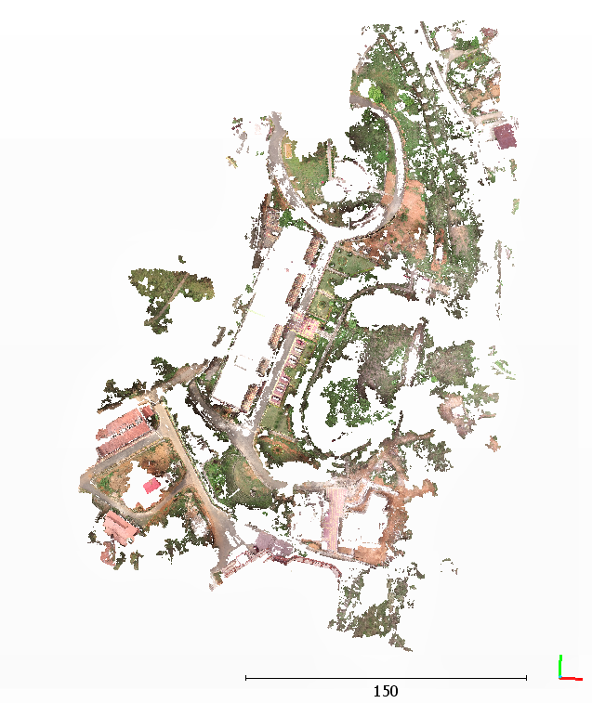 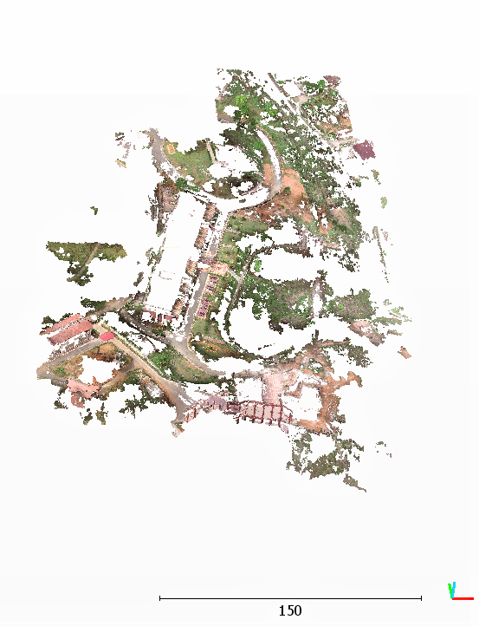

Figure 3.15: The point cloud containing only those areas which are part of ground that is used to train the model

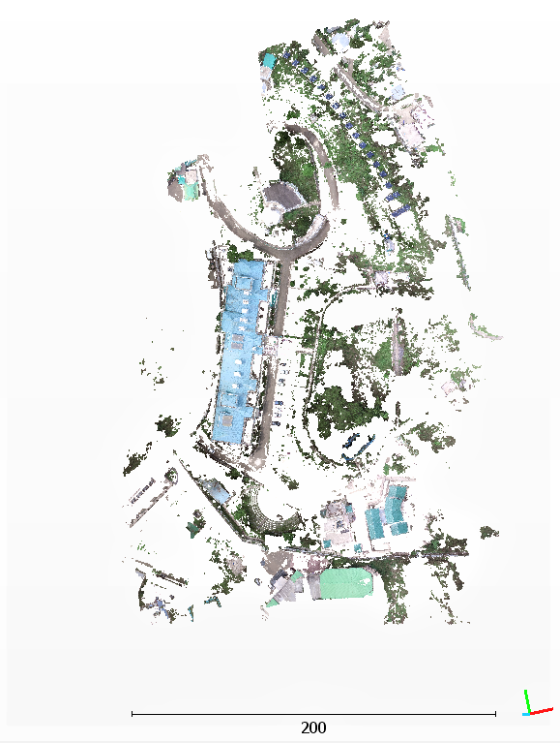 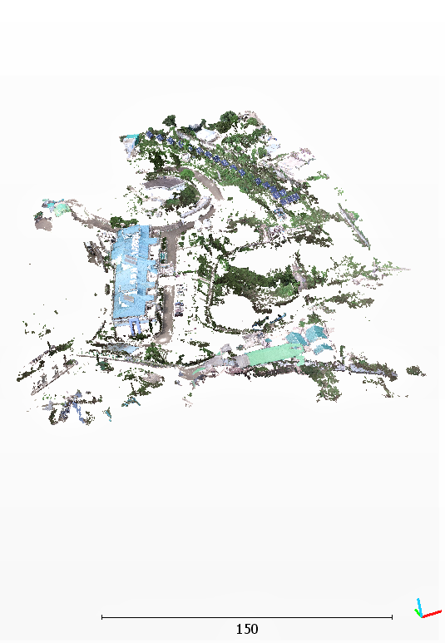

Figure 3.16: The point cloud containing only those areas which are not a part of ground that is used to train the model.

**Dataset 4: Vegetative and non-vegetative areas with a combined training set**

We have formed a training data for which we took multiple point cloud to address the variability in the same class. We took the two segmented classes from the earlier point cloud that we already have and segmented two more new point clouds into the two classes then we clubbed them together. To train the model we have chosen three parameters as Red, Green and Blue and have left the Z coordinate. This is because there was way more variations in the Z coordinate for the different point clouds.

 

Dfrd

erdfefed, Green and Blue and hasclouds. and has left the Z coordinate.this is because there was way more variations in the Z coo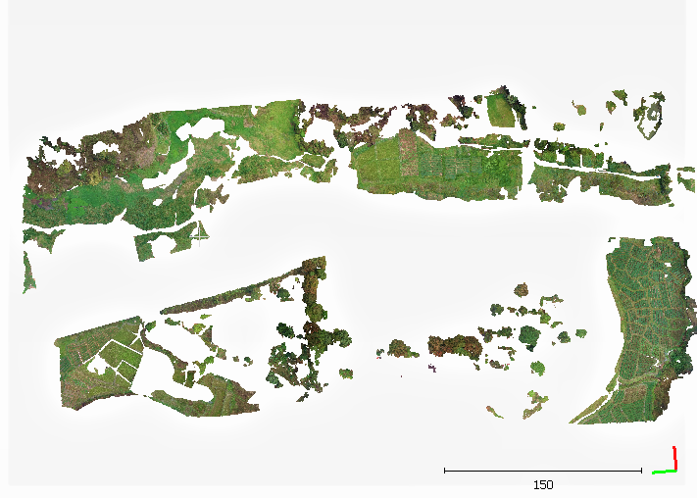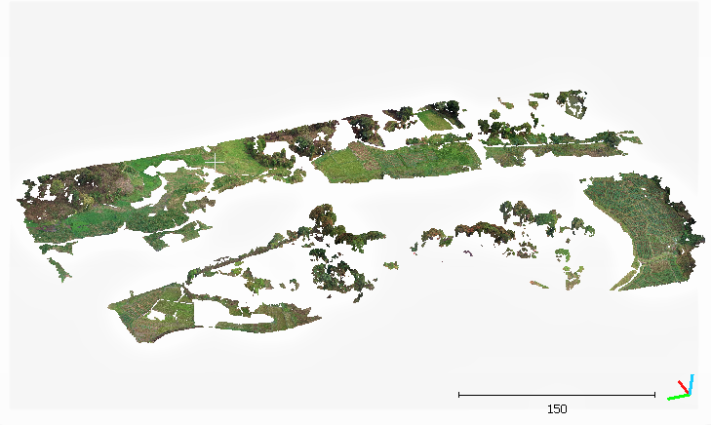

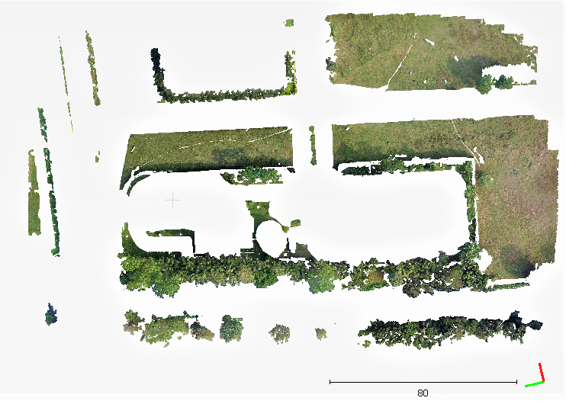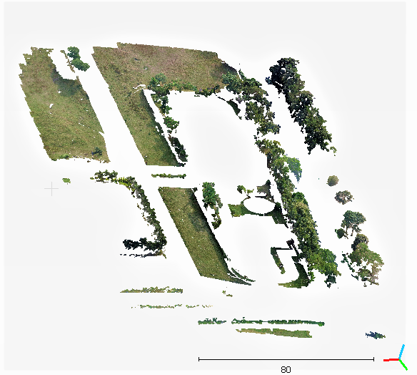

Figure 3.17: the point cloud containing only the areas with vegetation that is use to train the model

 

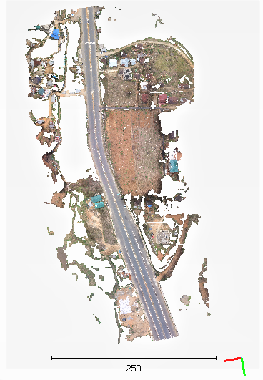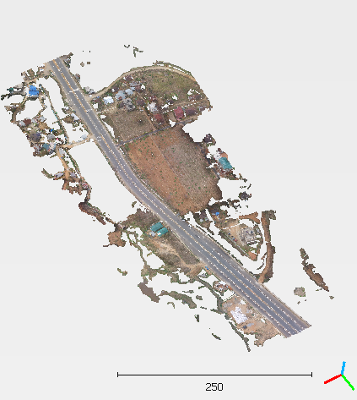

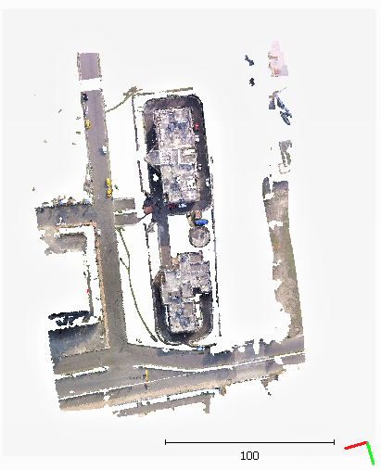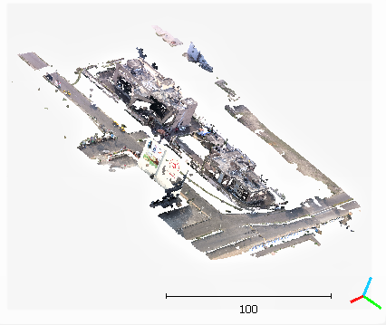

Figure 3.18: the point cloud containing only the areas without vegetation that is used to train the model

**4.6.4. Analysis of the models**

One of the key advantages of logistic regression is its ability to check the quality of the model produced. We have produced three models corresponding to three contrasting pairs of data and analysis of each model is given.

The analysis of the model is done based on certain measures these are as follows

**Confusion Matrix**

A confusion matrix is a summary of predicted results on a classification problem. In this matrix we come to know about the ways in which our classification model is confused when it makes predictions. It also helps us to know about the type of errors the model makes. The matrix is organized in following manner:

**Expected down the side**: Each row of the matrix corresponds to a predicted class.

**Predicted across the top**: Each column of the matrix corresponds to an actual class.

In case of two-class problem, we can represent confusion matrix as:

|  |  |  |  |
| --- | --- | --- | --- |
| |  | | --- | | Event No-event | | Event True positive False positive | | No-event False negative True negative | |

Where,

“**True positive**” for correctly predicted event values.

“**False positive**” for incorrectly predicted event values.

“**True negative**” for correctly predicted no-event values.

“**False negative**” for incorrectly predicted no-event values.

**Classification Report**

 A classification report is used to check the quality of classification algorithm predictions. It helps in displaying the precision, recall, F1, and support scores for the model

**Precision:**

For each class it is defined as the ratio of true positives to the sum of true and false positives. It is the ability of a classifier not to label an instance positive that is actually negative.

$$Precision = TP/(TP + FP)$$

**Recall:**

For each class it is defined as the ratio of true positives to the sum of true positives and false negatives. It is the ability of a classifier to find all positive instances.

$$Recall = TP/(TP+FN)$$

**F1 Score:**

The F1 score is a weighted harmonic mean of precision and recall such that the best score is 1.0 and the worst is 0.0. The weighted average of F1 should be used to compare classifier models.

Also F1 scores are lower in value than accuracy measures. It can be measured as –

$$F1 Score = 2*(Recall * Precision) / (Recall + Precision)$$

**Support:**   
Support is the number of actual occurrences of the class in the specified dataset. Imbalanced support in the training data may indicate structural weaknesses in the reported scores of the classifier and could indicate the need for stratified sampling or rebalancing.

Support = True Positive + False Positive

Support = (TP + FP)

The three models that are analyzed are as follows:

**Model 1: model classifying areas with and without vegetation**

The distributions of the points in the analysis were found to be as follows:

True positive, TP: 800099

True negative, TN: 5274577

False positive, FP: 54740

False negative, FN: 46947

$Precision = TP/(TP + FP)$ = 800099/ (800099+54740) = 0.94

$Recall = TP/(TP+FN)$ = 800099/ (800099 + 46947) = 0.94

$F1 Score=2*(Recall*Precision)/(Recall+Precision)$

$= 2*(0.94*0.94)/(.94+.94)$

$= 0.94$

**The % accuracy of the model $=$** {(TP+TN)/(TP + FP + FN+ TN )}*100%

$=\left\{\frac{800099+527457}{800099+54740+46947+527457 }\right\}*100\%$

= 92.88%

**Support** = ( TP + FP ) = ( 800099 +54740 ) = 854839

The given data is shown in tabular format as below:

1. **Classification report**

|  |  |
| --- | --- |
| **Parameters** | **measures** |
| precision | 0.94 |
| recall | 0.94 |
| F1 score | 0.94 |
| Support | 854839 |
| % accuracy | 92.88% |

1. **Confusion matrix for the test data :**

|  |  |  |
| --- | --- | --- |
|  | **Event** | **No event** |
| **Event** | 800099 | 54740 |
| **No event** | 46947 | 527457 |

**Model 2: model classifying areas with and without building**

The distributions of the points in the analysis were found to be as follows:

True positive, TP: 231687

True negative, TN: 287993

False positive, FP: 18705

False negative, FN: 13905

$Precision = TP/(TP + FP)$ = 231687/ (231687+18705) = 0.925

$Recall = TP/(TP+FN)$ = 231687/ (231687 + 13905) = 0.943

$F1 Score=2*(Recall*Precision)/(Recall+Precision)$

$= 2*(0.925*0.943)/(.925+.943)$

$= 0.93$

**The % accuracy of the model $=$** {(TP+TN)/(TP + FP + FN+ TN )}*100%

$=\left\{\frac{231687+287993}{231687+18705+13905+287993 }\right\}*100\%$

= 94.095%

**Support = (** TP + FP ) **= (** 231687 + 18705 ) = 250392

The given data is shown in tabular format as below:

1. **Classification report**

|  |  |
| --- | --- |
| **Parameters** | **measures** |
| precision | 0.94 |
| recall | 0.943 |
| F1 score | 0.93 |
| Support | 250392 |
| % accuracy | 94.095% |

1. **Confusion matrix for the test data :**

|  |  |  |
| --- | --- | --- |
|  | **Event** | **No event** |
| **Event** | 231687 | 18705 |
| **No event** | 13905 | 287993 |

**Model 3: model classifying ground and non-ground areas**

The distributions of the points in the analysis were found to be as follows:

True positive, TP: 537089

True negative, TN: 629143

False positive, FP: 256011

False negative, FN: 116847

$Precision = TP/(TP + FP)$ = 537089/ (537089+256011) = 0.677

$Recall = TP/(TP+FN)$ = 537089/ (537089 + 116847) = 0.821

$F1 Score=2*(Recall*Precision)/(Recall+Precision)$

$= 2*(0.821*0.677)/(.821+.677)$

$= 0.742$

**The % accuracy of the model $=$** {(TP+TN)/(TP + FP + FN+ TN )}*100%

$=\left\{\frac{537089+629143}{537089+256011+116847+629143 }\right\}*100\%$

= 75.77%

**Support = (** TP + FP ) **= (** 537089 + 256011 ) = 793100

The given data is shown in tabular format as below:

1. **Classification report**

|  |  |
| --- | --- |
| **Parameters** | **measures** |
| precision | 0.677 |
| recall | 0.821 |
| F1 score | 0.742 |
| Support | 793100 |
| % accuracy | 75.77% |

1. **Confusion matrix for the test data :**

|  |  |  |
| --- | --- | --- |
|  | **Event** | **No event** |
| **Event** | 537089 | 256011 |
| **No event** | 116847 | 629143 |

**Model 4: model classifying vegetation and non-vegetation areas with**

**combine dataset**

The distributions of the points in the analysis were found to be as follows:

True positive, TP: 2306366

True negative, TN: 1297798

False positive, FP: 165448

False negative, FN: 350457

$Precision = TP/(TP + FP)$ = 2306366/ (2306366+165448) = 0.93

$Recall = TP/(TP+FN)$ = 2306366/ (2306366 + 350457) = 0.8680

$F1 Score=2*(Recall*Precision)/(Recall+Precision)$

$= 2*(0.868*0.93)/(.868+.93)$

$= 0.897$

**The % accuracy of the model $=$** {(TP+TN)/(TP + FP + FN+ TN )}*100%

$=\left\{\frac{2306366+1297798}{2306366+165448+350457+1297798 }\right\}*100\%$

= 87.478%

**Support** = (TP + FP ) = ( 2306366 +165448 ) = 2471814

The given data is shown in tabular format as below:

1. **Classification report**

|  |  |
| --- | --- |
| **Parameters** | **measures** |
| precision | 0.93 |
| recall | 0.87 |
| F1 score | 0.897 |
| Support | 2471814 |
| % accuracy | 87.478% |

1. **Confusion matrix for the test data :**

|  |  |  |
| --- | --- | --- |
|  | **Event** | **No event** |
| **Event** | 2306366 | 165448 |
| **No event** | 350457 | 1297798 |

**4.6.5 Our observation**

After the training and testing of the model is done we have test the produced model on a totally unseen point cloud

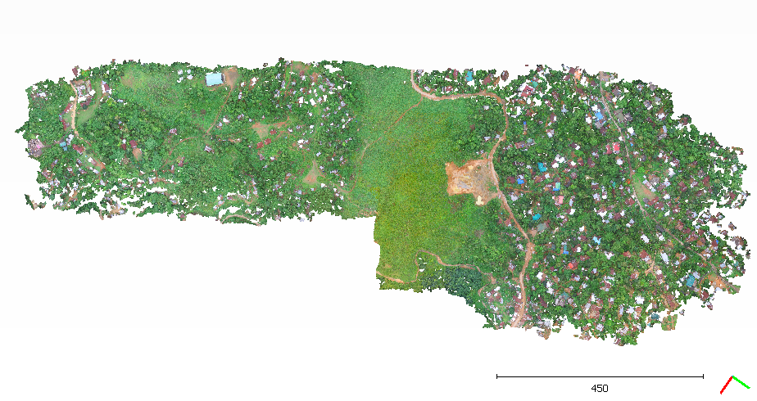

Figure 3.19: The unseen point cloud

**●Using our first model we got the following results.**

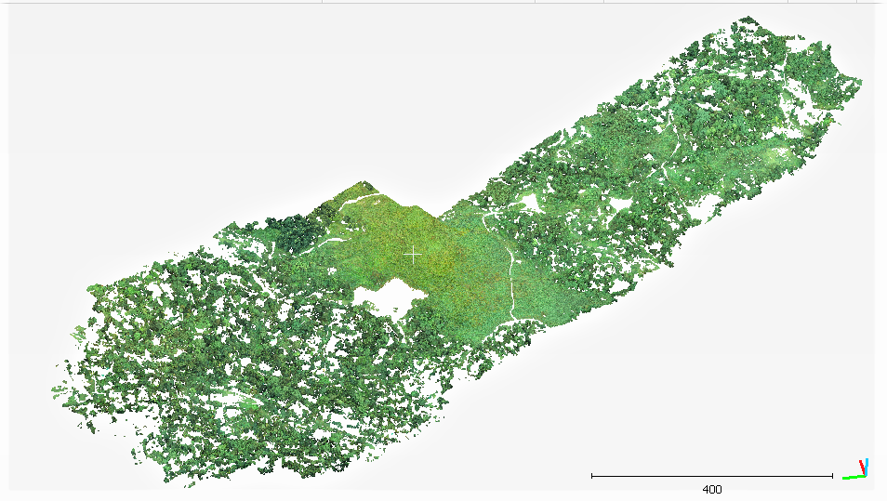 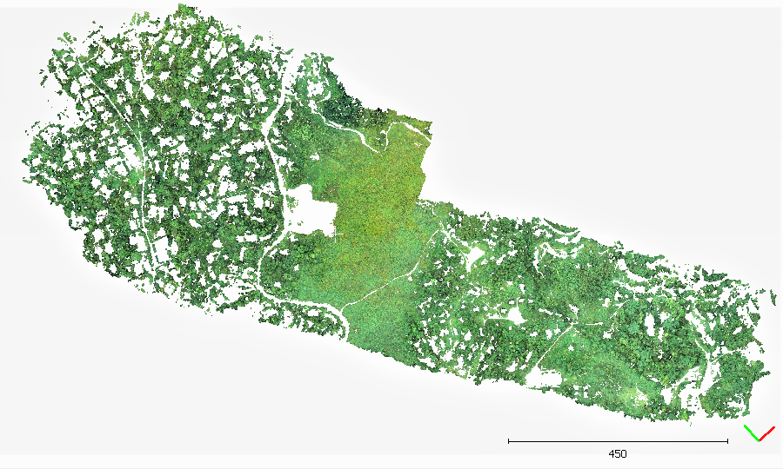

Figure 3.20: the area with vegetation

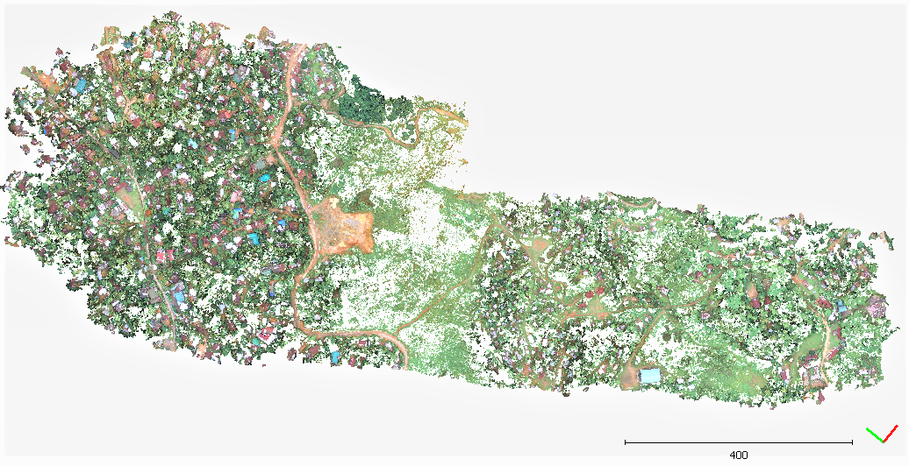 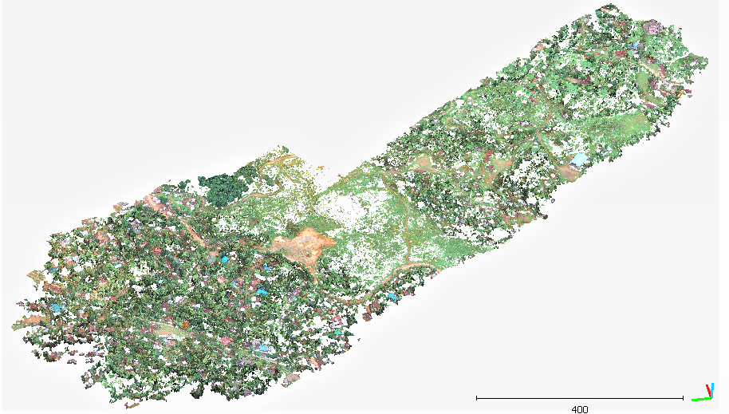

Figure 3.21: The area without vegetation.

We can clearly observe that the classification of the vegetative area from the rest of the area is quite satisfactory but however the area which the model claims to have only non vegetative portions only is definitely have a significant amount of noise.

**●The second model gives the following observations:**

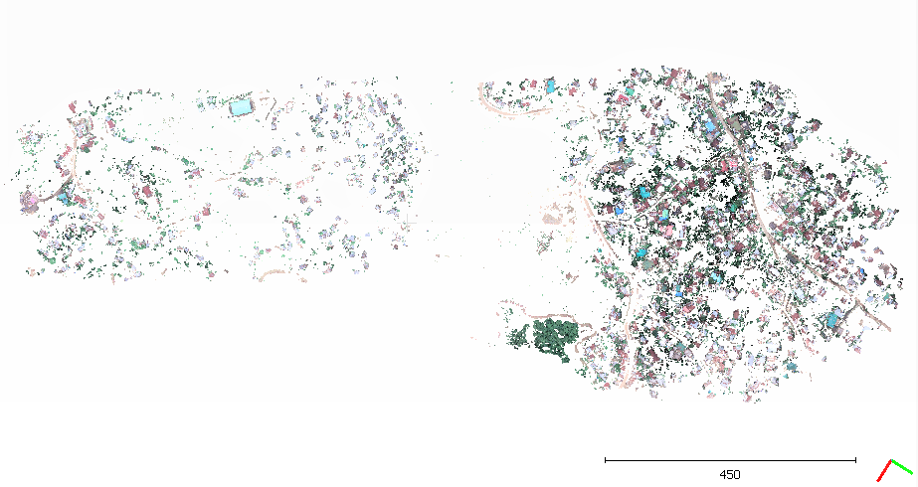

Figure 3.22: The area containing the buildings.

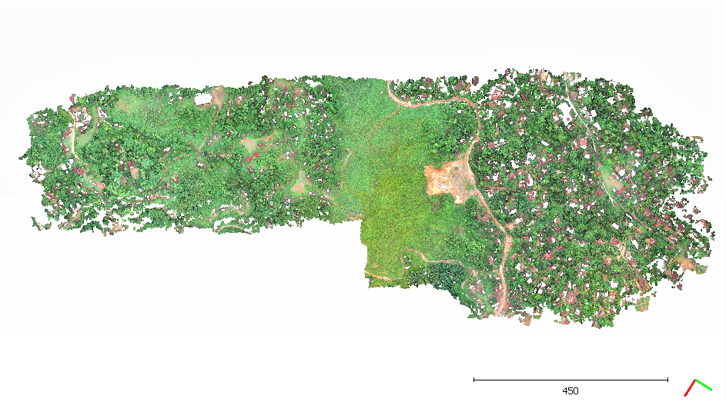

Figure 3.23: the area without the buildings

The second model performed quite brilliantly as we can observe that the portions with the buildings are segmented well enough from the main regions. But however it is quite evident that whenever the color of the top of the buildings are close to that for the ground then the classification is a bit faulty.

**●The third model gives the following observations:**

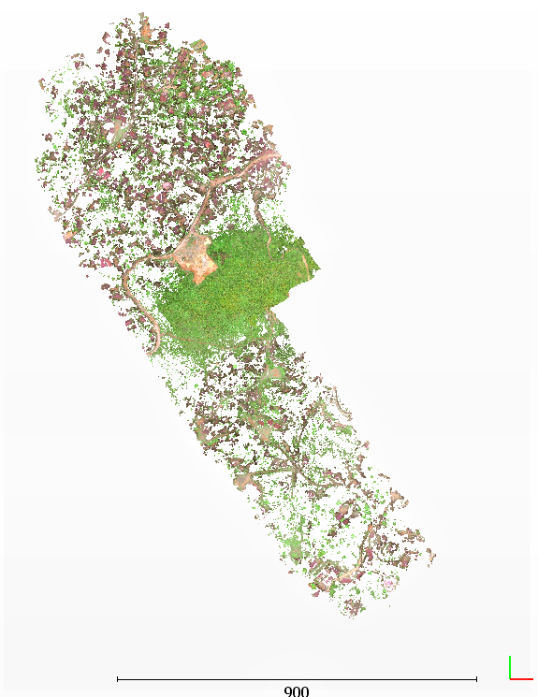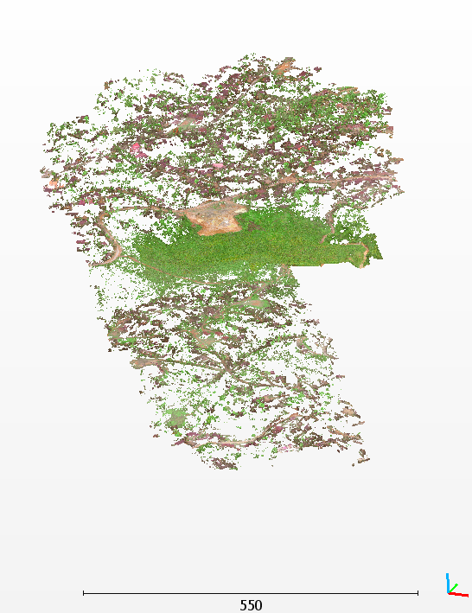

Figure 3.24: The ground area

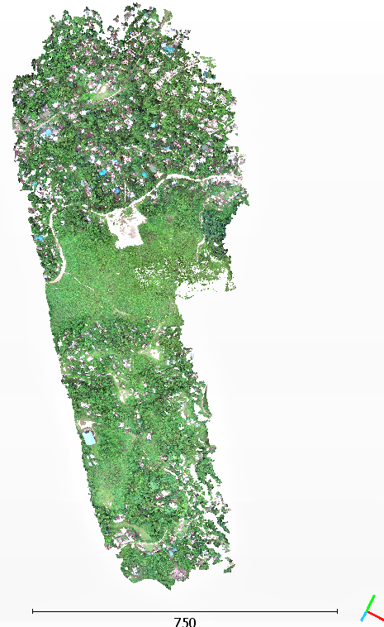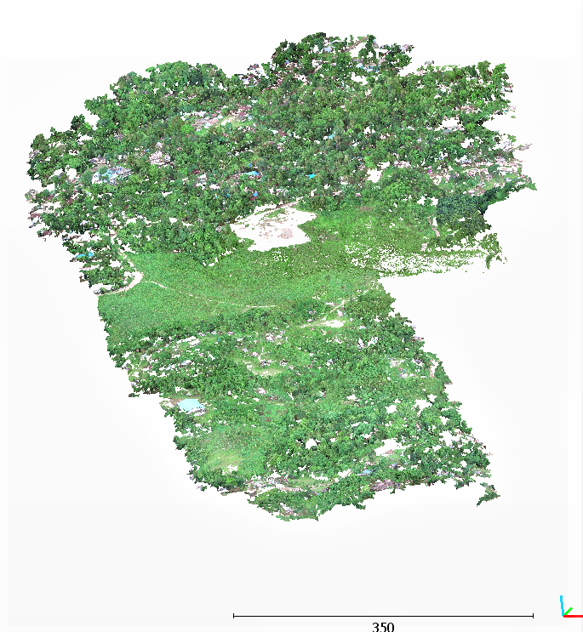 Figure 3.25: The non ground area.

The obtained results are quite good as we can see that the ground parts are relatively well separated from the non ground portions, except for a portion in the middle portion which seems common to both the sections.

**●The fourth model gives the following observations:**

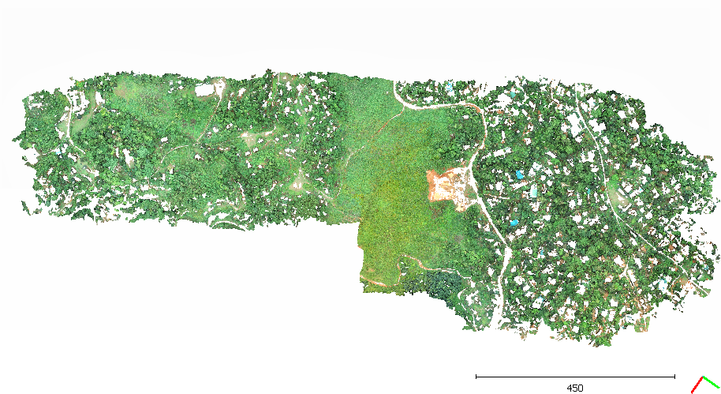

Figure 3.26: The area with vegetation.

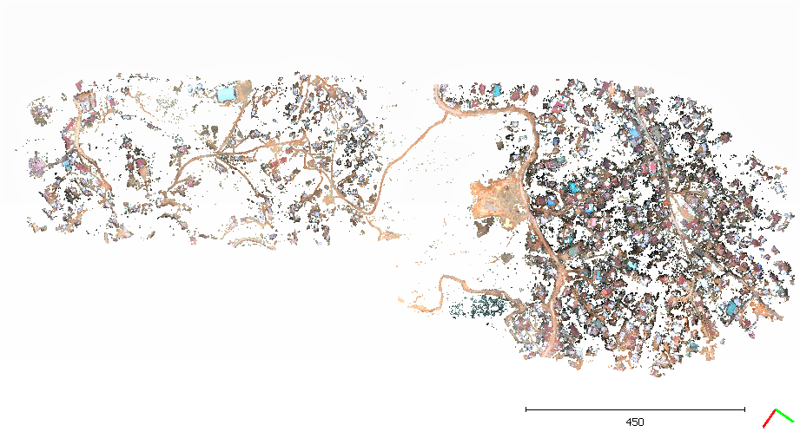 Figure 3.27: The area without vegetation.

We can clearly observe that the classification of the vegetative area from the rest of the area is quite satisfactory but however the area which the model claims to have only non vegetative portions only is definitely having some noise.

**4.6.6. Results**

We can clearly see the improvement of using logistic regression over K means which was obvious. Even though the accuracies are quite high but however it still don’t gives a cent percent results as can be seen in the first model. The accuracy depends highly on the train data and with increased in precision of the train data the outputs will also increase. Further if the variability within a single class is addressed then it can lead to a relatively high precision and accuracy.

**4.6.7. Inference**

**Advantages:**

1. It is a widely used technique because it is very efficient, does not require too many computational resources, it’s highly interpretable, it doesn’t require input features to be scaled, it doesn’t require any tuning, it’s easy to regularize, and it outputs well-calibrated predicted probabilities.
2. Logistic Regression is incredibly easy to implement and very efficient to train.
3. Like linear regression, logistic regression does work better when attributes that are unrelated to the output variable as well as attributes that are very similar (correlated) to each other are removed.
4. When applied on point cloud dataset it can classify on the basis of ‘r g b’ parameters with well enough accuracy.

**Disadvantages:**

1. Non-linear problems cannot be solved with logistic regression since it is decision surface is linear.
2. Logistic regression is not a useful tool unless you have already identified all the important independent variables. Since its outcome is discrete, Logistic Regression can only predict a categorical outcome.
3. Logistic regression algorithm is known for its vulnerability to over fitting.
4. Sometimes the model classifies the point cloud with poor accuracy. For example if a logistic model is trained using datasets from hilly areas and that model is applied on dataset from plane area then it can give some undesired outputs.

**4.7 Comparison between unsupervised and supervised approach: K-means and logistic regression**

●Using k means reduce the human effort of manually segmenting the data, as the algorithm is capable of segmenting the data itself.

●The accuracy of the supervised approach is superior to that of the unsupervised one

●Even though using k means recursively provides better result but it comes with the loss of point density (clearly visible in the comparison made at the next slide)

●Using python for both the approach’s implementation is relatively very easy as libraries are there which provides function that can be directly used.

●Quality of the model can be checked using logistic regression. Account of accuracy is provided which is impossible to obtain in k means.

**4.8 Conclusions**

After applying various machine learning techniques, we conclude that k-means is one of the simplest unsupervised learning algorithm that solve the well-known clustering problem. Its performance is better when there is less variation in the dataset from a single class. But from the observations it is seen that its results significantly decreases when there is more variations in the dataset. It is computationally faster and an easy and efficient technique for point cloud clustering but the accuracy is sacrificed.

Logistic Regression is one of the simplest supervised machine learning techniques. This technique is considered to be one of the easiest ways for making predictions. We found that the outcome of this technique is comparatively better than the K-means technique in terms of the accuracy it produces. Further it is even possible to get the measure of the accuracy in numbers which was not possible with K means. It is seen that it can classify point clouds with accuracy in a range of 70-90%. This technique provides good outcomes only when the dataset is well-labelled and accurate and provides poor results when the dataset does not fit it properly. While preparing the training data is a tedious process the output is relatively way better. However one down side to it is that even though many labelled data is available online, but for specific area of research there is a definite requirement to prepare dataset. Preparing the training dataset requires a lot of precision otherwise the results obtained would not be accurate.

**CHAPTER 5**

**A command line application for point cloud processing**

A command line application is developed for automatic processing and segmentation of point clouds which can be used in both windows and Linux (Ubuntu) platforms. Also new models can be trained and applied using this application. In this application one can train their own models for segmentation or can get segmented output directly by simply giving the input in ‘.csv’ format (*.las files can be easily converted to .csv format using pdal).

This application is developed using ‘python click’ library. Here segmentation is done using machine learning techniques. The entire application is written in python language. Various python libraries (like pandas, numpy, sklearn etc) are used here. This application is very easy to use and one can get desired segmented output using this application for example if one needs ground portions of a point cloud it can be done with only a few steps.

**Instructions:**

1. Convert the .las file to .csv (can use PDAL)
2. Open terminal
3. Navigate to the folder where the application is installed
4. For getting ground portions as output type command “ground”(For other use cases type other commands.).
5. Follow the instructions and get the output. The output will be in .csv format which can be easily converted to .las format.
6. --help command can be used if any help required.

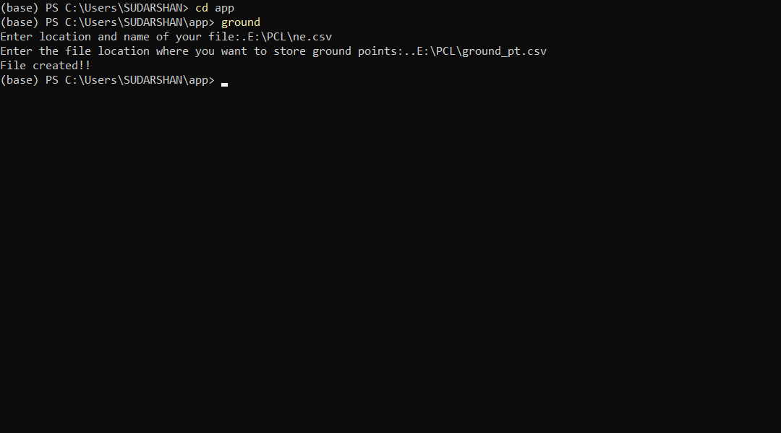

Figure: commands are run in the console.

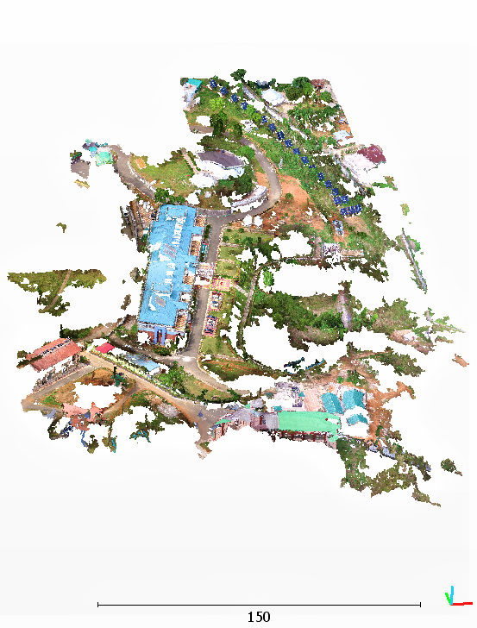

Figure: Original input file (No of points: 25, 40, 059 )

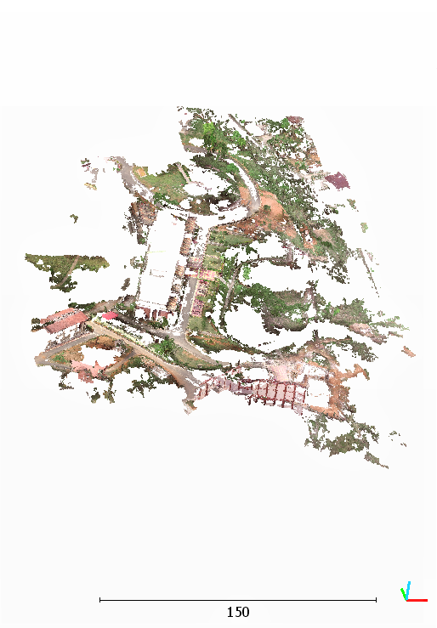

Figure: Output given by the application after using ground command (No of points: 11, 71, 669)

The software also comes with the extra feature in which the user can make their own model by using their labelled training data; it can be done using the following steps (Here an example is used for describing).

**Instructions**

1. If user wants to classify point cloud as ground and non-ground portions first he needs to convert datasets for both ground and non-ground points to .csv format.
2. Add a new column named “class” to both datasets.
3. The values of “class” column of one dataset should be zero and that of another must be one.
4. Now open the terminal.
5. Navigate to the folder where this application is installed.
6. Use command “train”
7. Follow the onscreen instructions.
8. Get the desired output in .csv format and convert it to .las format of visualisation.

This application is in developing stage. Many new features will be added soon. The major challenge is accuracy which will be improved.

**Conclusion**

This software that we have produced has used basic machine learning techniques for its processing and is still in its developing stage. The main motive of it is to provide a user friendly and easy to use platform which could analyse the point cloud.

**Reference**

1. A review of point clouds segmentation and classification algorithms; E. Grilli, F. Menna, F. Remondino

2. Classification of aerial photogrammetric 3D point clouds; C. Becker a, N. H¨ani b∗, E. Rosinskaya a, E. d’Angelo a, C. Strecha a

3. Learning Efficient Point Cloud Generation for Dense 3D object Reconstruction; Chen-HsuanLin, ChenKong, SimonLucey

4. Feature Extraction from Point Clouds; Stefan Gumhold, Xinlong Wangy

5. Text Information Extraction and Analysis from Images Using Digital Image Processing Techniques; Partha Sarathi Giri

6. Multi-View Stereo: A Tutorial; Yasutaka Furukawa Washington University in St. Louis furukawa@wustl.edu Carlos Hernández Google Inc. carloshernandez@google.com

7. Towards Internet-scale Multi-view Stereo; Yasutaka Furukawa1 Brian Curless2 Steven M. Seitz1, 2 Richard Szeliski3 1Google Inc. 2 University of Washington 3 Microsoft Research

8. PDAL: Point cloud Data Abstraction Library Release 1.9.1; Andrew Bell Brad Chambers Howard Butler Michael Gerlek PDAL Contributors

9. Close Range Photogrammetry Principles, techniques and applications; T Luhmann, S Robson, S Kyle and I Harley

10. “CLASSIFICATION AND SEMANTIC SEGMENTATION OF POINT CLOUDS: WHAT IS MISSING?”; Franz Rottensteiner

11. Automatic Three-Dimensional Point Cloud Processing for Forest Inventory; Jean-Franc¸ ois Lalonde, Nicolas Vandapel and Martial Hebert

12. Image Segmentation by Weighted Aggregation with Gradient Orientation Histograms; Rory Neilson Bashan Naidoo Stephen McDonald Member, SAIEE Member, IEEE

13. Structure from motion; K. S. Arun, T. S. Huang, and S. D. Blostein. Least-squares ﬁtting of two 3-d points sets. IEEE Transactions on Pattern Analysis and Machine Intelligence, 9(5):698–700, 1987

14. Comparison of Different Feature Sets for TLS Point Cloud Classiﬁcation; Quan Li * and Xiaojun Cheng

15. How to VisualSFM; Jacob A. Morgan & Daniel J. Brogan

16. PointNet: Deep Learning on Point Sets for 3D Classiﬁcation and Segmentation

17. Octree-based Region Growing for Point Cloud Segmentation; Anh-Vu Voa, Linh Truong-Honga, Debra F. Laefera,b,c, Michela Bertolottod

18. Combining Top-down and Bottom-up Segmentation; Eran Borenstein, Eitan Sharon, Shimon Ullman.

19. Close Range Photogrammetry Principles, techniques and applications; T Luhmann, S Robson, S Kyle and I Harley

20. A Progressive Morphological Filter for Removing Non ground Measurements From Airborne LIDAR Data; Keqi Zhang, Shu-Ching Chen, Member, IEEE, Dean Whitman, Mei-Ling Shyu, Member, IEEE, Jianhua Yan, and Chengcui Zhang, Student Member, IEEE

21.Classification of airborne laser scanning point clouds based on binomial logistic regression analysis; Cornelis Stal, Christian Briese, Philippe De Maeyer, Peter Dorninger, Timothy Nuttens, Norbert

22. Feature Extraction from Point Clouds; Stefan Gumhold, Xinlong Wang, Rob MacLeod

23. Eﬃcient Dense Point Cloud Object Reconstruction Using Deformation Vector Fields; Kejie Li, Trung Pham3, Huangying Zhan and Ian Reid

24. Uniformization and density adaptation for point cloud data via graph Laplacian; Chuanjiang Luo Xiaoyin Ge Yusu Wang